Icons

Overview

The following navigation and operation icons are used throughout this documentation. Refer to this list for descriptions and keyboard equivalents.

 | New – clears the current form in order to enter new data. | Ctrl+N
 | Add to end – used in grid entry to add a new record after the last current row. | Ctrl+A
 | Insert before – used in grid entry to insert a new record before the currently selected row. | Ctrl+Shift+A
 | Delete current record – if focused in header portion of header/detail form, prompts for deletion of header and all detail; if focused in a detail grid, deletes current row. | Alt+Del
 | Save current record – saves current record in a grid, or header and all detail records if in a header/detail form. | Ctrl+S
 | Refresh data – refreshes current display. | Alt+F5
 | Run process – used in Options Entry forms after selections have been made to run the associated program. | F5
 | Print current record – prints the currently displayed record to the Document Output window | Ctrl+P
 | First record – navigates to the first record in a table when in Maintenance Grid mode. | Alt+Page Up
 | Previous record - navigates to the previous record in a table when in Maintenance Grid mode. | Page Up
 | Next record - navigates to the next record in a table when in Maintenance Grid mode. | Page Down
 | Last record – navigates to the last record in a table when in Maintenance Grid mode. | Alt+Page Down
 | Record Query - Invokes the inquiry subsystem to view records from the table associated with a form. | Ctrl+Q
 | Find – used to display a list of candidate records when in a validated field. | Ctrl+F
 | Expand record – used to display full contents of the record underlying a validated field. | Ctrl+E
 | Calendar – launches a graphical calendar for use in date fields. | Ctrl+L
 | Launch link – launches the specified URL
 | Drilldown – launches a user-specified drilldown definition. | Ctrl+D
 | Options – dropdown menu containing optional processes, such as subsidiary forms or reports. | Ctrl+O
 | Close – closes the active window. | Ctrl+F4

Operations

Overview

The Operations section contains descriptions of the General Ledger tasks. A sample of each screen is shown. Each field is described, and the operation of each task is explained. Examples of each report and register are also provided. Use this section as a reference when using the Accounts Payable menu options.

About the General Ledger Tasks
Tasks in General Ledger are grouped into areas of operation. Common tasks, such as journal entries or account allocation entries, are stand-alone tasks that are accessed directly from the main menu; tasks that work in concert with one another, such as budgeting tasks or period end processing tasks, are accessed through a sub-menu off the main menu.

The General Ledger Main Menu contains two sub-menus providing access to the many reports available for the analysis of general ledger information. The Reports sub-menu contains the standard reports offered with the module. The Custom Financials sub-menu contains tasks allowing you to custom design reports and statements to fit your company’s unique needs. Apart from these, there is a sub-menu each for Budgeting, Period End Processing, Maintenance and Utilities.

In addition,, some tasks have several options for complete processing. For example, you can use the Account Maintenance to access summary activity information, transaction history maintenance, comment inquiry, etc. These processes are selectable from an option menu.

General Ledger Main Menu
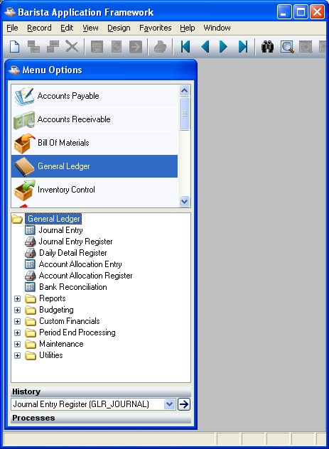
General Ledger Main Menu

Function
The General Ledger Main Menu provides access to all the tasks in the General Ledger module, including those in the Budgeting, Custom Financials, Period End Processing, General Ledger Maintenance and Utilities menus. Using this menu, you can make journal entries, print reports and registers and close accounting periods.

n To access the General Ledger Main Menu...

Select General Ledger from the AddonSoftware Menu Options.

Journal Entry
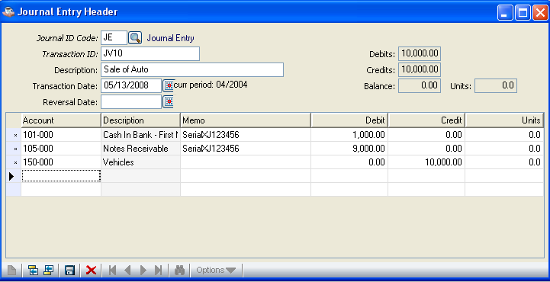
Journal Entry

Function
This task is used to make journal entries directly to the general ledger without having to enter transactions in the subsidiary modules. Journal entries may be made at any time during the accounting period and are updated to the general ledger with the Journal Entry Register and the Daily Detail Register.

n To access this task...

Select Journal Entry from the General Ledger Processing Menu.

About the Fields
Journal entry is a header/detail form. At the top of the form, enter Journal ID code, Transaction ID, Description, Transaction Date and Reversal Date. In the detail grid, enter the details of the account to be credited and the account to be debited. Any transaction may be recalled, modified or deleted up until the time it is updated.

In the Journal ID Code field...
• Enter a valid two character Journal ID code (e.g., JE for Journal Entry).

- Click Find to select from a list of all valid codes.

Clicking on Find displays the following screen:-

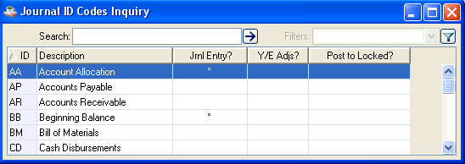

The Journal ID Codes Inquiry screen displays all valid codes that are selectable for processing.

Each Journal ID code must be defined through the Journal ID Code Maintenance task to allow entries to be made using the code. When entering a Journal ID Code that does not exist, the system issues the following prompt:-

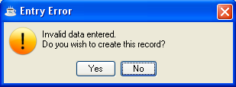

Press No to cancel and return to the Journal Entry Header screen. Press Yes to create a new Journal ID Code by entering details in the following screen: -

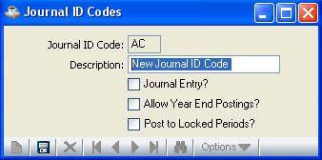

- Enter a description for the new Journal ID Code.
- Check the Journal Entry? checkbox for new Journal Entry.
- Check the Allow Year End Postings? checkbox to allow year end postings to this Account Head.
- Check the Post to Locked Periods? checkbox to allow posting to Locked Periods.

When you have selected the desired options,

- Click Save to add the details of the new Journal ID Code.

When you click on Save, the system issues the following prompt:-

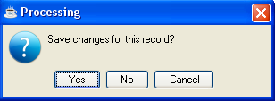

Press Yes to save the details of the new Journal ID Code.
Press No to cancel and return back to the Journal Entry Header screen.
Press Cancel to return to the Journal ID Codes screen and make any modifications to the previously entered details before saving.

In the Transaction ID field...
• Enter a transaction ID for this journal entry of up to 10 characters long.

Each ID defines a unique transaction and is carried into the general ledger after updating. A common practice is to use a sequential numbering scheme (e.g. JV10, JV11, JV12, etc.) when entering your transaction IDs. This is because multiple journal entries with the same date are grouped by the Journal ID and Transaction ID code on the Journal Entry Register.

In the Description field...
This field is optional.
• Enter a description up to 30 characters long.

- Press Return to bypass the field.

This field helps describe the overall purpose of the journal entry and will print on the Journal Entry Register. The description does not carry into the general ledger after updating.

Description Example
Inventory Adjustment

In the Transaction Date field...
• Enter the date in the MMDDYY format.
- Click Calendar to select date using the calendar control.
- Press Return to bypass the field.

The period updating the entry is displayed to the right of the transaction date. When the transaction falls into a future period, the entry will be updated into that period. If it falls into a prior period, a warning message will be issued and the entry will be posted into the current period unless the Post To Locked Periods? flag for the Journal ID Code you are using is set to Y.

In the Reversal Date field...
This field is optional.
• Enter a date in the MMDDYY format to reverse this transaction.
- Click Calendar to select date using the calendar control.

- Press Return to bypass the field.

Use this field when you want to automatically have this transaction reversed on the specified date. When a reversal date is entered, a second journal entry is automatically created, appears on the general ledger daily report, and will automatically update the general ledger as an exact reversal of the first entry.

In the Debits field...
Display only. Shows the total amount of debits for this journal entry.

In the Credits field...
Display only. Shows the total amount of credits for this journal entry.

In the Balance field...
Display only. Shows the balance for this journal entry.

Line Detail Entry
Each Journal Entry is a two-step process requiring a detail line for the debit and another for the credit. Each line contains information regarding the account number, description, and amount of the entry.

For a new transaction, the system automatically accesses the Account field.

When it is an existing transaction, previously entered information is displayed.

In the Account field...
• Enter a valid GL account number. The description of the account will be displayed.

- Click Find to select from a list of all valid accounts.

Clicking Find displays the following screen:-

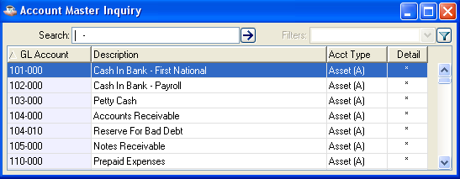

The Account Master Inquiry screen displays a list of all available accounts that are selectable for processing.

In the Memo field...
This field is optional.
• Enter a memo of up to 30 characters to further identify each line item of the journal entry.

This memo will appear on the Journal Entry Register, Daily Detail Register and be carried into the Transaction History file in the general ledger.

In the Debit field...
- Enter the debit amount for this line item.

Press Tab to move to the Credit field.

In the Credit field...
• Enter the credit amount for this line item.
- Press Tab to move to the Units field.

In the Units field...
This field is optional.
• Enter the number of units for this line item.

- Press Tab to move to the next line Account field.

This field only appears when the Units parameter is set to Y in the General Ledger Parameter Maintenance task.

Units Example
You could enter the number 7 if the transaction involved renewal of 7 vehicle licenses.

When you have finished entering information into the line detail fields, press
Save to add the Journal Entry Header details.

Journal Entry Register
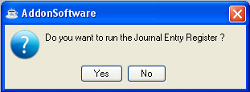
Journal Entry Register

Function
This task is used to print a register of all journal entries entered through Journal Entry or updated from the Recurring Journal Entry Register. After printing, the option is given to update the account information to the general ledger Daily Detail file.

n To access this task...

Select Journal Entry Register from the General Ledger Processing Menu.

A sample copy of the printed register is shown below:-

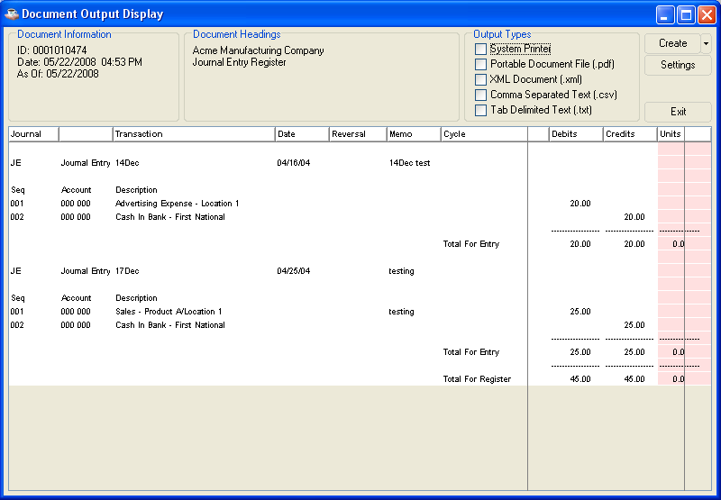

Printing

Once the register has printed, the system issues the prompt:

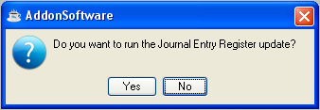

• Press Yes when the register printed correctly and balanced to the totals expected.

- Enter No if the register did not print correctly or the update should be postponed.

Updating
The information is updated to the Daily Detail file. The Journal Entry table is cleared as part of the update.

Daily Detail Register
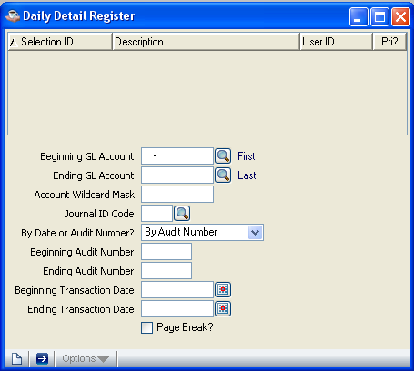
Daily Detail Register

Function
This task prints a list of all general ledger transactions entered through journal entries or generated from other modules. After the report, you will be given the option to update to the general ledger Summary Activity and Transaction History files. Refer to Appendix A, for a sample copy of the printed register.

n To access this task...

Select Daily Detail Register from the General Ledger Processing Menu.

About the Fields

In the Beginning GL Account field...
• Enter a valid beginning account number.

-or-
Press the Find field records button to select from a list of all valid accounts.

In the Ending GL Account field...
• Enter the ending account number for the register.

-or-
Press the Find field records button to select from a list of all valid account numbers.

In the Account Wildcard Mask field...
• Enter the wildcard mask to be used in selecting from the above accounts. Refer to Wildcard Mask under Collecting the Data in the Installation section for more information.
-or-
Press Return to go to the next field when no wildcard mask should be used.

In the Journal IDCode field...
• Enter any journal ID to include on the register.

-or-
Press the Find field records button to select from a list of all valid journal ID codes.

In the By Date Or Audit Number field...
• Select By Date from the dropdown list to generate the register by date.
-or-
Select By Audit Number from the dropdown list to generate the register by audit number.

In the Beginning Audit Number field...
• Enter the beginning audit number/date for the register.

In the Ending Audit Number Or Date field...
• Enter the ending audit number/date for the register.

In the Beginning Transaction Date field...
• Enter the beginning date for the register.
-or-
Press the Display Calendar button to bypass the field.

In the Ending Transaction Date field...
• Enter the ending audit number/date for the register.
-or-
Press the Display Calendar button to bypass the field.

In the Page Break field...
• Select the checkbox for a page break with each change in the audit number/date.
-or-
Unselect the checkbox to omit the page break.

Printing
The report is sorted by date or audit number, journal ID, and account number.

If you selected all accounts and journal IDs for all dates to be printed, the system issues the prompt:

Are You Ready to Update the Daily Detail Register?

• Enter Yes when the register printed correctly and balanced to the totals expected.
-or-
Enter No if the register did not print correctly or if the update should be postponed.

NOTE: When errors are discovered during the generation of the register, the update prompt will not be issued. If you are having a problem with updating the register, some common errors and possible solutions are listed in Appendix B.

Updating
The transactions will be updated to the General Ledger Transaction History file. The General Ledger Summary Activity file will be updated with the net activity for each account.

Account Allocation Entry
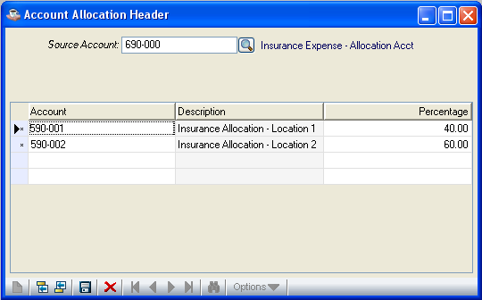
Account Allocation Entry

Function
This task allows automatic redistribution of a percentage of the balance in a general ledger account. The period used to take the balance is specified as part of the update (Refer to Account Allocation Register).

n To access this task...

Select Account Allocation Entry from the General Ledger Processing Menu.

About the Fields

In the Source Account field...
• Enter the account number of the account that is the source of the balance.
-or-
Press the Find field records button to select from a list of all valid account numbers.

When you enter an account not previously designated as a source account, the system issues the prompt:

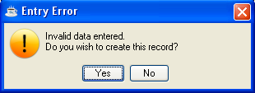
• Press Yes to continue entering the information for this account.
-or-
Enter No to return to the Source Account field.

Line Detail Entry
Each account allocation entry detail line contains information regarding the account number and the percentage of the source balance to be distributed to the account.

When this is a new allocation, the system automatically accesses the Account field.

NOTE: One hundred percent of the source account must be designated to other accounts. When you want to designate only 15% of a source account, enter 15% for the account to receive the fifteen percent and 85% back to the source account.

When this is an existing allocation, previously entered information is displayed and the system issues the prompt:

In the Account Number field...
• Enter a valid GL account number. The description of the account will be displayed.
-or-
Press the Find field records button to select from a list of all valid numbers.

In the Percentage field...
• Enter the percentage of the balance to be allocated.

NOTE: When less than 100% of the source account is to be transferred, include the source account as one of the destination accounts with the percentage to be retained.

• Press Return to accept the line details as correct.
-or-
Press Tab to move to the next and enter next account details.
-or-
Press Shift-Tab to move back through the fields.

When you have finished entering information into the line detail fields, press the Save current data button to save the details.

NOTE: Account Allocation entries created in one fiscal period do not carry over to other periods. They must be re-entered each period.

Account Allocation Register
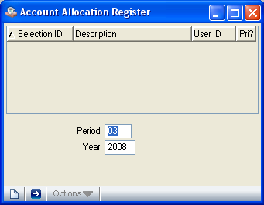
Account Allocation Register

Function
The Account Allocation Register provides a list of the account allocation entries, and allows you to specify which accounting period should be used to select the account balances. Refer to Appendix A, for sample copies of the printed register.

n To access this task...

Select Account Allocation Register from the General Ledger Processing Menu.

About the Fields

In the Period field...
• Enter an accounting period from which the account allocation source balance should be drawn.

NOTE: Allocations can only be made for the current fiscal year.

The ending balance for the selected period is used as the amount to be allocated to each detail line. The beginning and ending dates of the period will be displayed.

In the Year field...
• Enter the current fiscal year.

Printing

Once the register is printed the system issues the prompt:

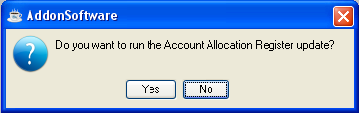
• Press Yes when the register printed correctly and balanced to the totals expected.
-or-
Press No if the register did not print correctly or if the update should be postponed.

Updating
The update process creates a transaction for each allocating entry in the Daily Detail file, where they may be updated to the general ledger after the printing of the Daily Detail Register.

Bank Reconciliation
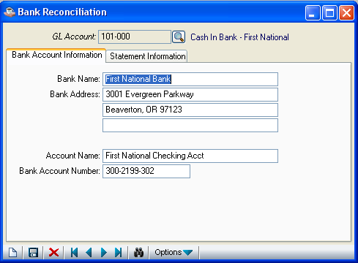
Bank Reconciliation

Function
You can use this task to add, delete, change and inquire into checking account information. All information associated with the account is accessed through an option menu that displays when you select an account.

■ To access this task...

Select Bank Reconciliation from the General Ledger Processing Menu.

About the Fields
This screen is divided into two sections. In the upper section you enter the account number and a description of the account is displayed. When an existing account is entered,
the lower section is filled up with the Bank Account Information and the Statement Information.

In the GL Account field...
• Enter the general ledger cash account number that identifies this checking account.
-or-

Press the Find field records button
for the lookup option.

The general ledger description is displayed, along with the details for reconciling the selected account.

About the Bank Reconciliation Lower Section
The Bank Reconciliation lower section allows you to enter varied information regarding an account without ever leaving the main task. By selecting available fields once an account is accessed, you can view, edit or delete existing account information, or add new data.

Along with the account number and description, any information previously entered for a field is displayed.

Bank Account Information

You can add, delete or change bank identification information, such as the account location, name, and bank-assigned account numbers, etc.

In the Account Name field…
• Enter 1 to 30 characters to identify the name of this account.

In the Bank Name field...
• Enter 1 to 30 characters to identify the name of the bank/branch.

In the Bank Address fields...
• Enter up to three lines of 30 characters each to identify the street, city/state, zip code and telephone number (if desired) of the above bank.

In the Bank Account Number field...
• Enter 1 to 15 characters to identify the bank-assigned account number.

When you press the button the system issues the primpt:

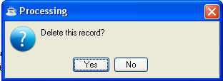
• Press Yes to delete all information for this checking account.
-or-
Press No to return back without deleting.

CAUTION: Be careful not to delete any necessary bank information as it can only be recovered from a backup, if available.

Statement Information
You can enter the bank statement ending date, ending balance, and current bank balance from the general ledger account. This option reconciles the general ledger account to the corresponding bank account using the bank statement and transactions recorded against the account.

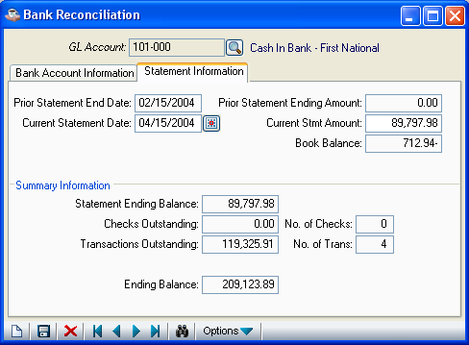

In the Prior Statement End Date field…
Display only. The ending date of the prior bank statement is displayed.

This date is updated using the Current Ending Stmt Date field each time the account is indicated as “balanced”.

In the Prior Statement Ending Amount field...
Display only. The ending balance of the prior statement is displayed.

This amount is updated using the Current Ending Statement Balance field each time the account is indicated as “balanced”.

In the Current Statement Ending Date field...
• Enter the ending date from the current bank statement.

In the Current Stmt Amountfield...
• Enter the ending balance from the current bank statement.

Or
Press the Display Calendar button to select a date.

In the Book Balance field...
Display only.

• The balance as of the statement ending date is shown.

Press the Save current data button to save the details.

After saving the details, the Summary Information is updated as follows: -

In the Statement Ending Balance field...
Display only. Shows the current statement ending balance as entered above.

In the Checks Outstanding field...
Display only. Shows the number and total amount of outstanding checks with a date less than, or equal to, the current statement ending date entered above.

In the Transactions Outstanding field...
Display only. Shows the number and total amount of outstanding other transactions with a date less than, or equal to, the current statement ending date entered above.

In the Ending Balance field...
Display only. Shows the calculated ending balance, based on what was entered for the starting balance (from the bank statement), less checks outstanding, plus transactions outstanding.

This amount is compared to the Current Book Balance.

When your accounts are in balance, the system issues the prompt:

This Account Is In Balance. Do You Wish To Remove All Paid Transactions?

• Enter Y to remove the transactions. The Current Stmt Ending Date/Amount fields are updated.
-or-
Enter N to return to the option menu without removing the transactions.

CAUTION: Be sure to print a Detail Listing of all transactions before entering Y to the above prompt. Once paid transactions are removed it is not possible to recover them except from a backup, if available.

If there is a difference between the two, the system issues the prompt:

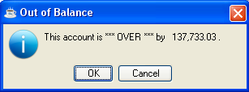
This prompt means the calculated bank balance is greater than/less than the general ledger balance as of the current statement ending date.

The system issues the prompt:

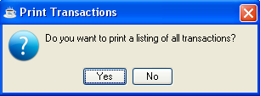?

• Enter Y to print a list of all transactions for this account.
-or-
Enter N to return to the option menu without printing the listing.

Detail Listing
Use this option to list all transactions on file for the selected bank account, which can be used to help with the reconciliation process. Print a final version of this report for future reference after the account is balanced. Refer to Appendix A, for a sample of the listing.

When you enter this task, the system immediately issues the prompt:

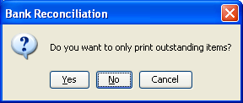
• Enter Yes to print a list of outstanding checks and transactions only.
-or-
Enter No to print a list of all checks and transactions, regardless of their status.

General Ledger Reports Menu
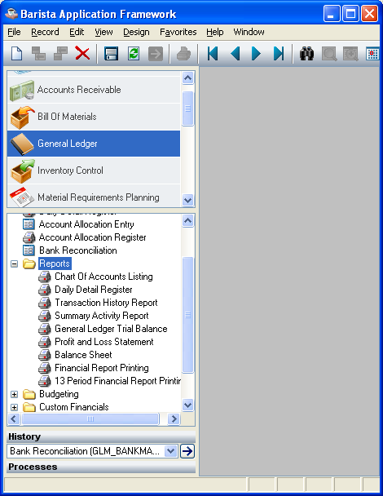
General Ledger Reports Menu

Function
The general ledger reports, statements and listings are all compiled on this menu to make it easier for you to access them. Use this menu when you want to print history reports, profit and loss statements, balance sheets, etc.

n To access this task...

Select General Ledger Reports Menu from the General Ledger Main Menu.

About the General Ledger Reports Menu Tasks
To access any report or listing on this menu, enter the number assigned to the task in the Enter An Option field.

Chart Of Accounts Listing
This task prints a listing of all account numbers on file and can be printed at any time. Accounts and their descriptions are listed in account numerical order. When chart of account breaks are defined, the corresponding title will be printed as each break is encountered. Refer to Appendix A, for a sample copy of the printed listing.

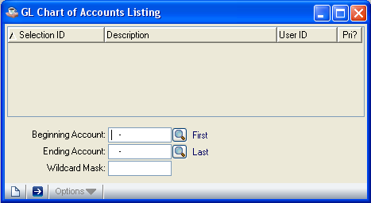

In the Beginning Account Number field...
• Enter a valid beginning account number.
-or-
Press F1 to select the first account number on file.
-or-
Press F3 to select from a list of all valid accounts.

In the Ending Account Number field...
• Enter the last account number to be shown on the listing.
-or-
Press F1 to select the last number on file.
-or-
Press F3 to select from a list of all valid account numbers.

In the Wildcard Mask field...
• Enter the wildcard mask to be used in selecting from the above accounts. Refer to Wildcard Mask under Collecting the Data in the Installation section for more information.
-or-
Press F1 for none.
The system will issue the prompt:

Is The Above Information Correct?

• Enter Y to print the listing.
-or-
Enter N to make changes to the fields.
-or-
Press F4 to return to the General Ledger Reports Menu without printing.

Printing
As the listing prints, the account numbers are displayed to show its progress.

Daily Detail Register
This is the same register accessible from the Main Menu. Refer to Appendix A, for a sample copy of the printed register.

GL Transaction History Report
This report allows you to print a transaction history for selected periods and lists the individual transactions within those periods. The information available in the Summary Activity Inquiry option of the Account Maintenance task is shown. You can print a history on one account or a range of accounts. You can also create a report showing detailed information or a summary of information. The report can be run at any time, and should always be run as part of the period end processing. Refer to Appendix A, for sample copies of the printed report.

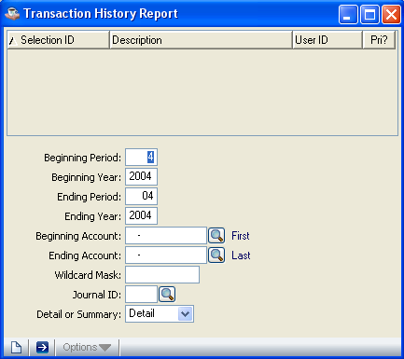

In the Beginning Period field...
• Enter the beginning accounting period you want shown on the report.
-or-
Press F1 to select the first period of the year.

In the Beginning Year field...
• Enter the fiscal year for the beginning period.

In the Ending Period field...
• Enter the last accounting period you want shown on the report.
-or-
Press F1 to select the last period of the year.

In the Ending Year field...
• Enter the fiscal year for the ending period.

In the Beginning Account Number field...
• Enter a valid beginning account number.
-or-
Press F1 to select the first account number on file.
-or-
Press F3 to select from a list of all valid accounts.

In the Ending Account Number field...
• Enter the last account number you want shown on the report.
-or-
Press F1 to select the last number on file.
-or-
Press F3 to select from a list of all valid account numbers.

In the Wildcard Mask field...
• Enter the wildcard mask to be used in selecting from the above accounts. Refer to Wildcard Mask under Collecting the Data in the Installation section for more information.
-or-
Press F1 for none.

In the Journal ID field...
• Enter any Journal ID to include on the report.
-or-
Press F1 to include all.
-or-
Press F3 to select from a list of all valid codes.

In the Detail or Summary field...
• Enter D when you want a detailed listing of all transactions by journal ID for each period selected.
-or-
Enter S when you want the report summarized.

The system will issue the prompt:

Is The Above Information Correct?

• Enter Y to print the listing.
-or-
Enter N to make changes to the fields.
-or-
Press F4 to return to the General Ledger Reports Menu without printing.

Printing
As the report prints, the account numbers are displayed to show its progress.

Summary Activity Report
This report provides a listing by account number showing summary activity for the period. The listing can be used to print actual or budget amounts; dollar or unit amounts; current, next year, or prior year amounts/budgets; and can be printed for all accounts/budgets or a limited range of accounts/budgets. This report can be printed at any time. Refer to Appendix A, for a sample copy of the printed report.

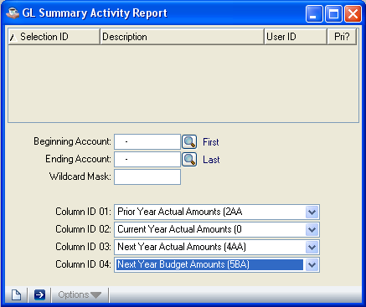

In the Beginning Account Number field...
• Enter a valid beginning account number.
-or-
Press F1 to select the first account number on file.
-or-
Press F3 to select from a list of all valid accounts.

In the Ending Account Number field...
• Enter the last account number for the report.
-or-
Press F1 to select the last account number on file.
-or-
Press F3 to select from a list of all valid account numbers.

In the Wildcard Mask field...
• Enter the wildcard mask to be used in selecting from the above accounts. Refer to Wildcard Mask under Collecting the Data in the Installation section for more information.
-or-
Press F1 for none.

In the ID fields...
• Enter the source ID of the file to be displayed.
-or-
Press F1 for none.
-or-
Press F3 to select from a list of all valid IDs.
-or-
Press Return to accept the default as set in the Default Display Columns task.

This field determines the account balances to be printed. Up to four combinations of balances may be selected on each report. Refer to Appendix C for a definition of Source ID Codes.

In the Type fields...
This field is bypassed when you selected N in the Use Units? field of the Parameter Maintenance task.
• Enter A to display amounts.
-or-
Enter U to display units.

In the Description fields...
Display only. Shows the description given to the budget in the Revision Code Maintenance task. For source IDs 0-5, the descriptions and titles are provided by AddonSoftware.

After all source IDs are entered the system issues the prompt:

Is The Above Information Correct?

• Enter Y to print the listing.
-or-
Enter N to make changes to the fields.
-or-
Press F4 to return to the General Ledger Reports Menu without printing.

Printing
As the report prints, the account numbers are displayed to show its progress.

General Ledger Trial Balance
The General Ledger Trial Balance prints the beginning balance, activity for the period, and ending balance for each account in the chart of accounts. Subtotals are printed for each general ledger account category as defined by the Chart of Account Breaks option of the General Ledger Parameter Maintenance task. A total for all debits and credits is also shown. This report can be run at any time, and should always be printed as part of the period end process. Refer to Appendix A, for sample copies of the printed report.

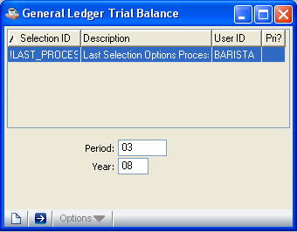

In the For Period field...
• Enter an accounting period.

The beginning and ending dates of the period will be displayed. The period-to-date and ending balance columns on the trial balance will include all postings through the end of the selected period.

In the For Year field...
• Enter the fiscal year of the period.

The year will be appended to the month and day of the general ledger period selected to determine which year’s transactions will be included in the Trial Balance Report.

The system will issue the prompt:

Is The Above Information Correct?

• Enter Y to print the report for the period shown.
-or-
Enter N to make changes to the fields.
-or-
Press F4 to return to the General Ledger Reports Menu without printing.

Printing
As the report prints, the account numbers are displayed to show its progress.

Profit & Loss Statement
This task provides a simple profit and loss statement. Accounts may be grouped, and subtotals generated, depending on any chart of accounts breaks defined in the Parameter Maintenance task. Period to Date and Year to Date totals are listed for each income and expense account. Refer to Appendix A, for a sample copy of the printed statement.

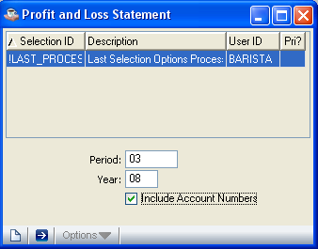

In the For Period field...
• Enter an accounting period.

The beginning and ending dates of the period will be displayed. The period-to-date and year-to-date columns on the Profit & Loss Statement will include all postings through the end of the selected period.

In the For Year field...
• Enter the fiscal year of the period.

In the Include Account Numbers field...
• Enter Y to include the general ledger account numbers on the report.
-or-
Enter N to print the statement without the account numbers.

The system will issue the prompt:

Is The Above Information Correct?

• Enter Y to print the report for the period shown.
-or-
Enter N to make changes to the fields.
-or-
Press F4 to return to the General Ledger Reports Menu without printing.

Printing
As the report prints, the account numbers are displayed to show its progress.

Balance Sheet
This task provides a simple balance sheet. Subtotals are provided for assets, liabilities, and capital; and period retained earnings are calculated. Additional subheadings and subtotals may be defined by the Chart of Accounts Breaks option of the Parameter Maintenance task. Refer to Appendix A, for a sample copy of the printed statement.

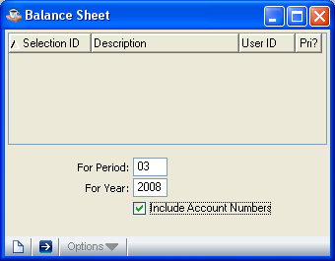

In the For Period field...
• Enter an accounting period.

The beginning and ending dates of the period will be displayed. The balance will include all postings through the end of the selected period.

In the For Year field...
• Enter the fiscal year of the period.

In the Include Account Numbers field...
• Enter Y to include the general ledger account numbers on the report.
-or-
Enter N to print the statement without the numbers.

The system will issue the prompt:

Is The Above Information Correct?

• Enter Y to print the report for the period shown.
-or-
Enter N to make changes to the fields.
-or-
Press F4 to return to the General Ledger Reports Menu without printing.

Printing
As the report prints, the account numbers are displayed to show its progress.

Financial Report Printing
This task prints any or all financial reports defined and linked to the general ledger chart of accounts. Data stored in the General Ledger Masterfile is used to calculate information required for the reports. This task is also available through the Financial Report Maintenance Menu. Refer to Appendix A, for sample copies of the printed reports.

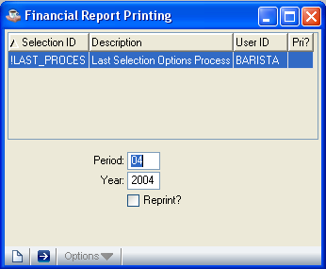

In the For Period field...
• Enter an accounting period.

The beginning and ending dates of the period will be displayed. The year-to-date column on the financial report will include all postings through the end of the selected period.

In the For Year field...
• Enter the fiscal year of the period.

The system will issue the prompt:

Is The Above Information Correct?

• Enter Y to access the report selection fields.
-or-
Enter N to make changes to the fields.
-or-
Press F4 to return to the General Ledger Reports Menu without printing.

When you select Y at the above prompt, the report selection display is accessed. Use this display to select printing any or all of the different reports created through the Financial Report Maintenance menu.

In the Report field...
• Enter a valid report number.
-or-
Press F1 to select all reports.
-or-
Press F3 to select from a list of all valid reports.

In the Description field...
Display only. Shows the name of the report.

When you have finished selecting reports, press F4 to access the Is The Above Information Correct? prompt again.

• Enter Y to print the selected reports.
-or-
Enter N to make changes to the fields.
-or-
Enter L to display the report entries one screen at a time.
-or-
Enter R to display the report entries one report at a time.
Press Return to accept the report for printing.
-or-
Enter D at the end of a detail line for a specific report to remove the report from the printing process. When F1 is used to select all reports, enter R to access the report to be deleted.
-or-
Enter Reprint to print the reports without updating.
-or-
Press F4 to return to the General Ledger Reports Menu without printing.

Updating
As the general ledger information is updated to the financial report, the general ledger account numbers are displayed on the screen.

Printing
As the report prints, the account numbers are displayed to show its progress.

Reprinting
The reprint option will bypass the update cycle. However, when the reports are modified and none of the account number linkages are changed, a reprint will update new totals. Reprinting can be very useful when multiple copies of reports are needed.

13 Period Financial Report Printing
This report allows you to select reports in the same manner as the Financial Report Printing task. However, the financial information on this report represents the summary activity for the period selected and the previous 12 periods. Summary activity is retained for the prior, current, and next fiscal year. When summary activity is not available for 12 previous periods, then only the available summary activity will be printed.

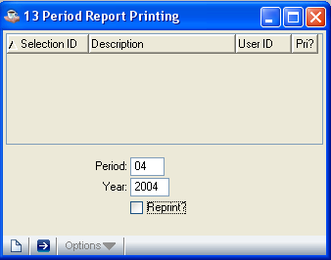

The periods are those defined in the Fiscal Calendar option of the Parameter Maintenance task. This task is also available through the Financial Report Maintenance Menu. Refer to Appendix A, for sample copies of a printed report.

In the For Period field...
• Enter an accounting period.

In the For Year field...
• Enter the fiscal year of the period.

The system will issue the prompt:

Is The Above Information Correct?

• Enter Y to access the report selection display.
-or-
Enter N to make changes to the fields.
-or-
Press F4 to return to the General Ledger Reports Menu without printing.

When you select Y at the above prompt, the report selection display is accessed. Use this display to select printing for any or all of the different reports created through the Financial Report Maintenance menu.

In the Report field...
• Enter a valid report number.
-or-
Press F1 to select all reports.
-or-
Press F3 to select from a list of all valid reports.

In the Description field...
Display only. Shows the name of the report.

When you have finished selecting reports, press F4 to access the Is The Above Information Correct? prompt again.

• Enter Y to print the selected reports.
-or-
Enter N to make changes to the fields.
-or-
Enter L to display the report entries one screen at a time.
-or-
Enter R to display the report entries one report at a time.
Press Return to accept the report for printing.
-or-
Enter D at the end of a detail line for a specific report to remove the report from the printing process. When F1 is used to select all reports, enter R to access the report to be deleted.
-or-
Enter Reprint to print the reports without updating.
-or-
Press F4 to return to the General Ledger Reports Menu without printing.

Printing
As the report prints, the account numbers are displayed to show its progress.

Reprinting
The reprint option will bypass the update cycle. However, when the reports are modified and none of the account number linkages are changed, a reprint will update new totals. Reprinting can be very useful when multiple copies of reports are needed.

General Ledger Budgeting
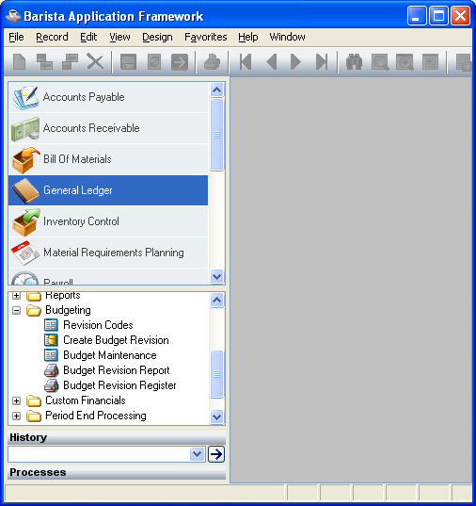
General Ledger Budgeting

Function
The General Ledger Budgeting menu is used to access tasks that create, change, or delete budget revisions. The different tasks available allow you to create new budgets, copy existing budgets and increase or decrease the figures by a certain percentage or amount, or to print budget reports. Budgets can be named for inclusion on other reports, such as Summary Activity, in the General Ledger module.

n To access this menu...

Select General Ledger Budgeting Menu from the General Ledger Main Menu.

About the General Ledger Budgeting Tasks
To access any task on this menu, enter the number assigned to the task in the Enter An Option field.

Revision Code Maintenance
Use this task to assign codes that will identify your budgets. Up to 26 budgets can be defined with these codes; one for each letter of the alphabet. Amounts and/or Units budgets may be created for each revision code. Refer to Appendix A, for a sample copy of the printed codes.

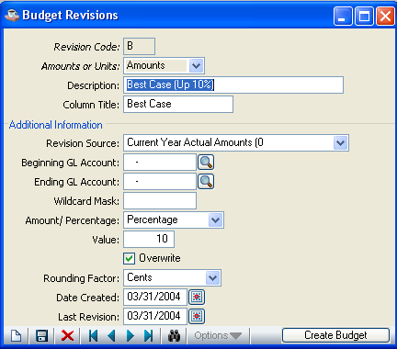

With this task, you create the parameters that define the calculation of your budget revisions. Prior, current, next year actuals, or any other budget, may serve as a starting point for the budget revision. You can also generate a budget for a selected range of accounts, and optionally, increase or decrease the amounts by a flat amount or a percentage.

In the Revision Code field...
• Enter a revision code lettered A - Z.
-or-
Press F3 to select from a list of all valid codes.
-or-
Press F4 to return to the General Ledger Budgeting Menu.

In the Amounts or Units field...
• Enter A when the fields apply to amounts.
-or-
Enter U when the fields apply to units.

When the system recognizes a new revision code, it issues the prompt:

Is This A New Record?

• Enter Y for a new revision code and proceed with entering information.
-or-
Enter N to return to the Revision Code field.

In the Description field...
• Enter a description for this revision code.

In the Column Title field...
• Enter an abbreviated title for the budget as it will appear on other reports and screens, such as the Account Maintenance Report, Budget Revision Report, Summary Activity Report and Inquiry, etc.

In the Revision Source field...
• Enter a Source ID to use for your budget figures. Refer to Appendix C for information on how Source IDs work.
-or-
Press F3 to select from a list of all valid Source IDs.

NOTE: The source may be account summary balances, budgets, or any other budget revision.

In the Beginning Account Number field...
• Enter a valid beginning account number.
-or-
Press F1 to select the first account number on file.
-or-
Press F3 to select from a list of all valid accounts.

In the Ending Account Number field...
• Enter the ending account number for this budget revision.
-or-
Press F1 to select the last account number on file.
-or-
Press F3 to select from a list of all valid account numbers.

In the Wildcard Mask field...
• Enter the wildcard mask to be used in selecting from the above accounts. Refer to Wildcard Mask under Collecting the Data in the Installation section for more information.

In the Amount/Percentage field...
• Enter A to increase or decrease the source amount by a fixed amount.
-or-
Enter P to increase or decrease the source amount by a fixed percentage.

In the Value field...
• Enter the amount/percentage the source amount will be increased/decreased.

In the Overwrite field...
• Enter Y to overwrite any previous budget record.
-or-
Enter N to leave any previous record as is.

In the Rounding Factor field...
• Enter C to round off the budget amounts to cents (1234.56).
-or-
Enter D to round off the budget amounts to dollars (1235.00).
-or-
Enter H to round off the budget amounts to the nearest hundred dollars (1200.00).
-or-
Enter T to round off the budget amounts to the nearest thousand dollars (1000.00).

This field determines how the calculated budget value will be rounded.

In the Date Created field...
Display only. Shows the date this budget revision was created.

In the Last Revision field...
Display only. Shows the last date this budget was revised.

The system will issue the prompt:

Is The Above Information Correct?

• Enter Y to accept the fields as shown.
-or-
Enter N to return to the Description field.
-or-
Enter Delete to remove all information associated with this revision.
-or-
Press F4 to return to the General Ledger Budgeting Menu.

If you choose to delete the budget revision information, the system issues the prompt:

OK to Purge All Records For The Budget Revision?

• Enter Yes to continue removing the budget revision information. There will be no record that this budget revision was ever created.
-or-
Enter No to return to the previous prompt.

When you exit this task by pressing F4, the system issues the prompt:

Print A List Of All Records?

• Enter Y to print a listing of all budget revisions.
-or-
Enter N to return to the General Ledger Budgeting Menu without printing.

Create Budget Revision
This task is used to generate budgets for individual accounts by period, using the parameters established in Revision Code Maintenance. After budget generation, you may use the Budget Revision Maintenance task or the Budget Revision Report to review the results. Budget Revision Maintenance can be used to make small adjustments. For adjustments on a larger scale, change the parameters within the Revision Code Maintenance task.

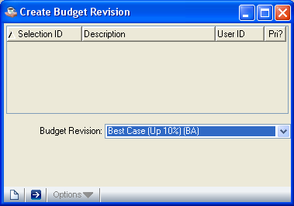

In the Revision Code field...
• Enter the revision code of the budget you want to create or update.
-or-
Press F3 to select from a list of all valid codes.
-or-
Press F4 to return to the General Ledger Budgeting Menu.

In the Amounts or Units field...
• Enter A to generate budgets for amounts.
-or-
Enter U to generate budgets for units.

NOTE: The combination of the selected revision code and amounts/units must be previously defined in Revision Code Maintenance.

The previously entered parameters for the budget you selected will be displayed and the system will issue the prompt:

Is The Above Information Correct?

• Enter Y to create the budget revision.
-or-
Enter N to return to the Revision Code field without processing the budget.

Budget Creation
As the budget is updated, the account numbers being updated are displayed on the screen. Amounts/Units are read for the selected accounts and are modified based on the parameters entered.

Budget Revision Maintenance
Use this task to view, compare, and maintain budget amounts for your different accounts. Budget values (amounts or units) can be added, deleted, or changed within this task. Up to four columns of values are displayed for the selected account. The initial columns are determined in the Budget Maintenance section of the Default Display Columns option of the Parameter Maintenance task. The columns being displayed may be changed at any time and may be different based on user preference.

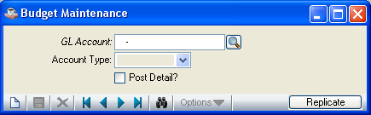

In the Account field...
• Enter the account number you want to view.
-or-
Press F3 to select from a list of all valid account numbers.
-or-
Press F4 to return to the General Ledger Budgeting Menu.

When you select an account number, the information associated with that number is displayed on the screen based on the current column selections. The system issues the prompt:

Is The Above Information Correct?

• Enter Y when all information is correct. You will be returned to the Account field.
-or-
Enter N to make changes to the fields. Only budget amounts can be changed.
-or-
Press F1 to access the Display Columns window. Refer to next page.

In the Type field...
Display only. Shows the account type as defined in Account Maintenance.

In the Detail? field...
Display only. Shows the setting of the detail transactions flag set in Account Maintenance.

In the Period field...
Display only. Shows the periods set up in Parameter Maintenance.

In the Column fields...
Displays the columns you selected in the Default Display Columns option of Parameter Maintenance. Only columns showing budget amounts can be changed.
• Enter any changes to budget amounts.
-or-
Press F1 to access the next column.
-or-
Press Return to access the next period.
-or-
Press F4 to end the entering of values.

NOTE: The budgeted amount in the column’s Period 1 can be duplicated to all other periods for that column by pressing F3 from that field.

Using the F1 Change Columns Key
You can display up to four columns of values at a time. To change the columns that are displayed on the screen, press F1 at the Is The Above Information Correct? prompt of the Budget Revision Maintenance task. The Budget Revision Maintenance Display Columns window will be displayed listing the current column selections.

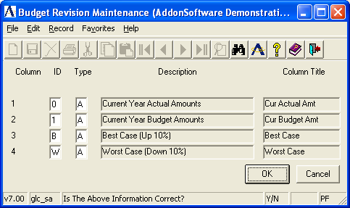

To make changes in the column display:
• Enter N at the prompt.

In the Column field...
Display only. Shows the column position.

In the ID fields...
• Enter the source ID of the file to be displayed.
-or-
Press F1 for none.
-or-
Press F3 to select from a list of all valid IDs.
-or-
Press Return to accept the default as set in the Default Display Columns task.

This field determines the account balances to be printed. Up to four combinations of balances may be selected on each report. Refer to Appendix C for a definition of Source ID Codes.

In the Type fields...
This field is bypassed when you selected N in the Use Units? field of the Parameter Maintenance task.
• Enter A to display amounts.
-or-
Enter U to display units.

In the Description fields...
Display only. Shows the description given to the budget in the Revision Code Maintenance task. For source IDs 0-5, the descriptions and titles are provided by AddonSoftware.

In the Column Title field...
Display only. Shows the title associated with the values and is what will be displayed on the Budget Revision Maintenance screen.

The system will issue the prompt:

Is The Above Information Correct?

• Enter Y to return to the Budget Revision Maintenance screen. The new columns will be displayed.
-or-
Enter N to return to the ID field.

Budget Revision Report
Use this task to print a hard copy of the budgets that you have generated. Refer to Appendix A, for a sample copy of the printed report.

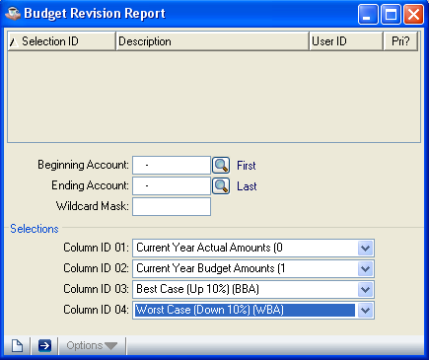

In the Beginning Account Number field...
• Enter a valid beginning account number for this report.
-or-
Press F1 to select the first account number on file.
-or-
Press F3 to select from a list of all valid accounts.

In the Ending Account Number field...
• Enter the last account number for the report.
-or-
Press F1 to select the last account number on file.
-or-
Press F3 to select from a list of all valid account numbers.

In the Wildcard Mask field...
• Enter the wildcard mask to be used in selecting from the above accounts. Refer to Wildcard Mask under Collecting the Data in the Installation section for more information.
-or-
Press F1 for none.

In the ID fields...
• Enter the source ID of the file to be displayed.
-or-
Press F1 for none.
-or-
Press F3 to select from a list of all valid IDs.
-or-
Press Return to accept the default as set in the Default Display Columns task.

This field determines the account balances to be printed. Up to four combinations of balances may be selected on each report. Refer to Appendix C for a definition of Source ID Codes.

In the Type fields...
This field is bypassed when you selected N in the Use Units? field of the Parameter Maintenance task.
• Enter A to display amounts.
-or-
Enter U to display units.

In the Description fields...
Display only. Shows the description given to the budget in the Revision Code Maintenance task. For source IDs 0-5, the descriptions and titles are provided by AddonSoftware.

The system will issue the prompt:

Is The Above Information Correct?

• Enter Y to begin printing. You will be returned to the General Ledger Budgeting menu.
-or-
Enter N to return to the Beginning Account Number field.
-or-
Press F4 to return to the General Ledger Budgeting Menu without printing.

Budget Revision Register
Use this task to print a hard copy of a budget revision and to update it to the current or next year budget. Each printed copy of the budget shows the different accounts affected by the budget and how much of the budget is allocated to each period. Part or all of the budget can be printed. Refer to Appendix A, for a sample copy of the printed register.

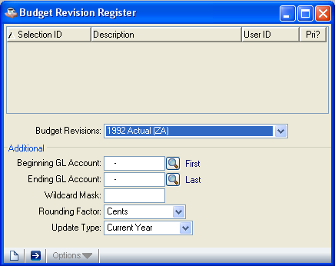

In the Revision Code field...
• Enter the revision code of the budget.
-or-
Press F3 to select from a list of all valid revision codes.
-or-
Press F4 to return to the General Ledger Budgeting Menu.

In the Amounts or Units field...
• Enter A to print amounts.
-or-
Enter U to print units.

NOTE: The combination of the selected revision code and amounts/units must be previously defined in Revision Code Maintenance.

The budget information of the revision code will be displayed and the system will issue the prompt:

Is The Above Information Correct?

• Enter Y to print the register.
-or-
Enter N to make changes to the fields.

NOTE: When you answer N to the above prompt the Beginning Account Number field is accessed. This enables you to print and update just part of your budget. When you want to access an entirely different budget, press F2 to move back to the Revision Code field.

In the Description fields...
Display only. Shows the description given to the budget in the Revision Code Maintenance task. For source IDs 0-5, the descriptions and titles are provided by AddonSoftware.

In the Column Title field...
Display only. Shows the title associated with the values and is what will be displayed on the Budget Revision Maintenance screen.

In the Beginning Account Number field...
• Enter the beginning account number to print.
-or-
Press F1 to select the first account number on file.
-or-
Press F3 to select from a list of all valid account numbers.

In the Ending Account Number field...
• Enter the last account number to print.
-or-
Press F1 to select the last account number on file.
-or-
Press F3 to select from a list of all valid account numbers.

In the Wildcard Mask field...
• Enter the wildcard mask to be used in selecting from the above accounts. Refer to Wildcard Mask under Collecting the Data in the Installation section for more information.

In the Rounding Factor field...
• Enter C to round off the budget amounts to cents (1234.56).
-or-
Enter D to round off the budget amounts to dollars (1235.00).
-or-
Enter H to round off the budget amounts to the nearest hundred dollars (1200.00).
-or-
Enter T to round off the budget amounts to the nearest thousand dollars (1000.00).

In the Update Current or Next field...
• Enter C to update the current year budget.
-or-
Enter N to update the next year budget.

Once you have made all changes to the fields and answered Y to the Is The Above Information Correct? prompt, the account numbers are displayed as the register is printed. When the printing is complete the system will issue the prompt:

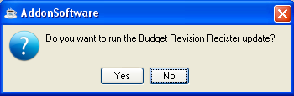
• Enter Y to update the register.
-or-
Enter N to return to the General Ledger Budgeting Menu without updating.

Financial Report Maintenance
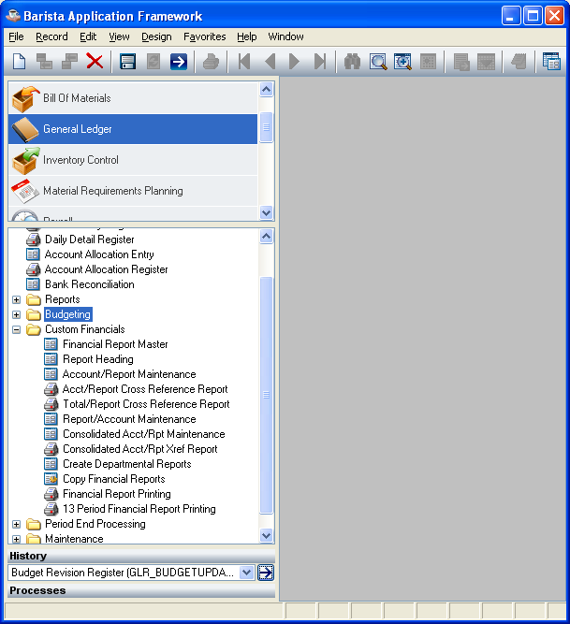
Financial Report Maintenance

Function
This menu allows access to the different tasks that enable custom financial reports to be set up, maintained and printed. These financial reports are entirely user-defined, and are formatted independently of the general ledger chart of accounts numbering scheme and account description. They are also independent of the standard financial reports provided on the general ledger reports menu.

Because financial report setup requires a good understanding of how to define and link the reports, be sure to refer to Financial Report Formatting in the Appendix section on how financial reports are set up and linked to the General Ledger.

n To access this task...

Select the Financials button from the General Ledger Main Menu.

About the Financial Report Maintenance Tasks
To access any task on this menu, enter the number assigned to the task in the Enter An Option field.

Financial Report Maintenance
This task creates, changes, displays and deletes financial report format information. An option menu allows the heading and detail information to be maintained or viewed on a report, and columns to be changed on an existing report.

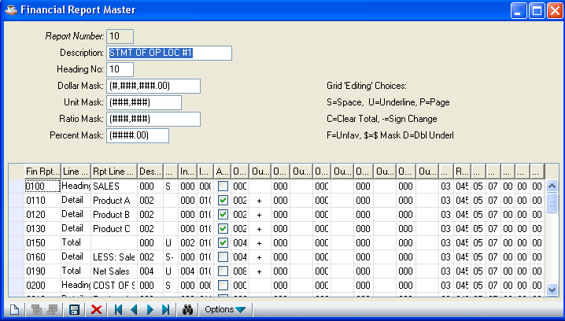

In the Report Number field...
• Enter a two digit report number.
-or-
Press Return to accept the next report in sequential order.
-or-
Press F3 to select from a list of all valid report numbers.
-or-
Press F4 to return to the Financial Report Maintenance Menu.

When a report number is entered that has not been defined, the system issues the following prompt:

Is This A New Record?

• Enter Y to establish the report; the program will automatically access the Heading Maintenance menu option.
-or-
Enter N if you do not want to set up a new report or you want to return to the Report Number field.

After you enter a valid report number in the Report Number field, the Financial Report Maintenance option menu appears. Work can continue on this report by selecting options from this menu.

About the Financial Report Maintenance Options.
The Financial Report Maintenance option menu allows you to work on one report after the other without ever leaving the Financial Report Maintenance screen. Once a report is accessed, you can view the report information, make changes to the report, or add and delete information by selecting available options from the menu.

Selecting an option takes you to that part of the report where the addition or modification will take place. When you select an option from the menu, the list of options disappears from the screen. After you have entered the changes to the report, the option menu will once again be displayed.

Prompts requiring your attention and pertaining to the selected option’s fields, appear at the bottom of the screen. Following are field descriptions for the Financial Report Maintenance options.

Report Number
Selecting this option returns you to the Report Number field where you can access one report after another without ever leaving the Financial Report Maintenance task. Refer to previous instructions.

Heading Maintenance
Each custom financial report has its own set of parameters which define the heading section, except for the actual report title which is set up in the Financial Heading Maintenance task. This option establishes the column types, column headings, and masks to be used. Up to eight columns can be defined for each report. The amount to be displayed for each column can be printed by accounting period, and can be specified by actual/budget/variance, unit type, and ratio/percent/dollars. Reports can also be deleted through this option.

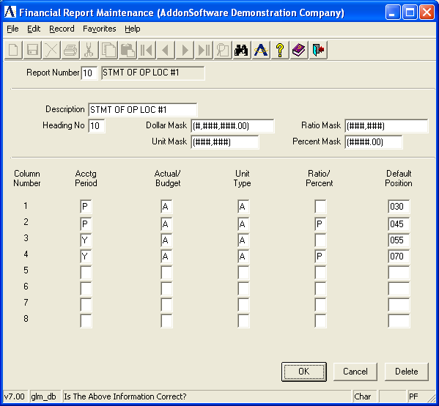

In the Report Number field...
• Enter a two-digit report number and a brief description of the report. The description is used for identification purposes only and does not actually appear on the report. Refer to How Financial Reports Are Interrelated in Appendix D for information on the importance of assigning report numbers.

In the Heading No field...
• Enter a two digit heading number. It is most common to use the same number as the report, thereby associating a specific heading with a report. Headings may, however, be used on more than one report. They refer to the portion of the report reserved for identification information such as company name, report date, or financial column headings.

NOTE: The heading number is not file verified at this time. This is because you may not know the final layout of the heading until the report format has actually been defined.

In the Dollar Mask field...
• Enter the mask to be used for dollar amounts.

This field establishes the format of the dollar mask to be printed on the report. Enter the format of the dollar mask using the following characters: #,.-0( ) CRDR. Be sure to allow for the size of totals, the number of columns and negative numbers. The maximum report width is 132 characters. For a complete discussion on defining dollar masks, refer to the Installation section regarding the setting up of general ledger parameters.

NOTE: The masks that are defined for financial report formatting are separate from the masks defined in the General Ledger parameters.

In the Unit Mask field...
• Enter the mask to be used for units.

This field establishes the format of the unit mask to be printed on the report. Enter the format of the unit mask using the following characters: #,.-0()CRDR. Be sure to allow for the size of totals, the number of columns and negative numbers. The maximum report width is 132 characters. The unit mask defined here is completely separate from the unit mask defined in the general ledger parameters, and will appear here even if the Unit parameter is set to N.

In the Ratio Mask field...
• Enter the mask to be used for ratios.

This field establishes the format of the dollars-per-unit or the units-per-dollar mask. Enter the format of the ratio mask using the following characters: #,.0()CRDR. Be sure to allow for the size of totals, the number of columns and negative numbers. The maximum report width is 132 characters. When you plan to express the ratio as dollars per units, make the mask larger. Refer to Financial Report Formatting, Appendix D, for more information on using ratios.

In the Percent Mask field...
• Enter the mask to be used for percentages.

This field establishes the format of the percent mask. Enter the format of the percent mask using the following characters: #,.0()CRDR. Remember that percentages may sometimes exceed 100% and may be negative numbers.

In the Column Number field...
Display only. Shows the column that will hold the figures.

Every financial report may have up to eight columns of figures and each column may vary depending on how the options are set. For more information, refer to Column Number in the How to Define the Heading Information section in Appendix D.

In the Acctg Period field...
• Enter P for current accounting period information.
-or-
Enter Q for current quarter-to-date accounting period information.
-or-
Enter Y for current year-to-date accounting period information.
-or-
Enter A for same accounting period information for the previous year.
-or-
Enter B for the year ago quarter-to-date accounting period information.
-or-
Enter C for the year ago-to-date accounting period information.

Note: 'To-date' means through the selected fiscal period.

In the Actual/Budget field...
• Enter A to display the actual amount for the selected accounting period.
-or-
Enter B to display the budgeted amount for the selected accounting period.
-or-
Enter V to display the variance between actual and budget for the selected accounting period.

In the Unit Type field...
• Enter A to display the amounts.
-or-
Enter U to display the units.

In the Ratio/Percent field...
• Enter R to display the amount/unit by ratio.
-or-
Enter P to display the amount/unit by percent.
-or-
Enter [ ] to display the amount/unit by dollars.
-or-
Enter $ to display the amount/unit showing the dollar variance of the previous two columns.
-or-
Enter % to display the amount/unit showing the percentage variance of the previous two columns.

NOTE: The $ and % variances apply to the previous two columns only. For example, if the first two columns contain dollar amounts, you could use the third column to show their $ variance. You could not use the fourth column to show their % variance, as it applies to the second and third columns.

A ratio is calculated by dividing the unit type specified by the opposite unit type (e.g., if the unit type is to be expressed as a dollar amount, dollars will be divided by units). A percent is calculated by dividing the unit type by the same unit type (dollars by dollars). Variances are calculated by subtracting one of the two previous columns from the other. If a dollar amount is to be displayed, no calculation will be performed.

In the Default Position field...
• Enter a number from 0-131 for the column position on the report.

NOTE: The number 31 may not be used.

This column number can be overridden in Detail Maintenance. See next page.

Default Position Example
Each column position should be increased a minimum of the mask length.
If column 1 is defined at position 60, and the amount mask is 15 characters long
(e.g., ##,###,###.00CR), then column 2 must be at least 75, or 60+15.

When you have finished entering report information, press F4 to leave the screen. The system issues the prompt:

Is The Above Information Correct?

• Enter Y if the information is correct and return to the Financial Report Maintenance options.
-or-
Enter N to make changes to the fields. You will be returned to the Description field.
-or-
Enter Delete to remove all information for this report.

Detail Maintenance
This option is used to define, view, or maintain the detail portion of a financial report format. Detail refers to the main body of a report. Through this option, each line of the report is assigned a type, a description, and a position. Special editing can also be performed to aid in formatting the report. The source, manipulation, and destination of each amount appearing on the printed financial reports is also established through this option.

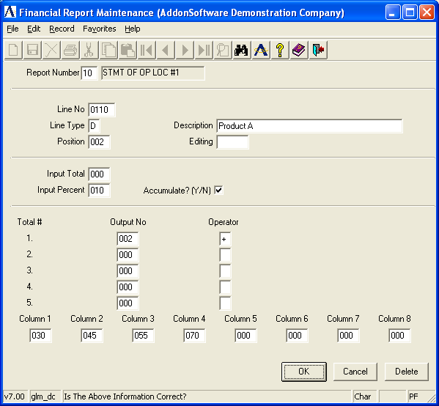

In the Line No field...
• Enter a number up to four digits in length.
-or-
Press Return to select the next sequential line number.
-or-
Press F3 to select from a list of valid line numbers.
-or-
Press F4 to return to the Financial Report Maintenance options.

This number is a sequential identification number that specifies the relative position of the line on the financial report. Lines should be numbered in steps of 5 or 10 so that additional lines can be easily inserted if necessary.

When you enter a valid line number in the Line No field, the detail information of that line is displayed. When a line number is entered and not defined, the system issues the following prompt:

Is This A New Record?

• Enter Y to add the line. The Line Type field will become activated.
-or-
Enter N if you do not want to set up a new line or you want to return to the Line No field.

In the Line Type field...
• Enter H to use this line as a heading line. Heading lines are used to display report titles, subheadings, memos, etc.
-or-
Enter D to use this line as a detail line. Detail lines containing the data from the general ledger accounts are added together during an update to find the totals. These are the only line types that will accumulate to a percent total.
-or-
Enter B to use this line as a beginning balance line. Beginning balance lines contain the period-beginning balance.
-or-
Enter C to use this line as a change in the account balance line. This amount reflects the change in value during the period.
-or-
Enter T to use this line for a total line. Total lines recall and print the totals for each column.
-or-
Enter N to use this line as a non-printing line. Non-printing lines do not appear on the report. They are used to indicate a blank line or perform a calculation that should not be printed, though it is used somewhere else in the report.

In the Description field...
• Enter a description up to 35 characters of the line.
-or-
Press Return to access the Position field without entering a description.

This field records the line description that is to print on the report for this specific line (e.g., Sales, Cost of Goods, etc.). The description will not be printed when the line is a non-printing line.

In the Position field...
• Enter a number from 0-131 as the position of the line description on the report.

NOTE: The number 31 may not be used.

This field defines the position on your computer paper where the description is to print. The print position plus the actual length of the description (not including trailing blanks) should not exceed 131, or an error can occur during the printing of the reports.

In the Editing field...
• Enter up to five editing letters or symbols from the list below.
-or-
Press Return to display this line without edits.

This field is used to specify special functions that can be performed before the line is printed. Punctuation is not needed. The following options are available:

S Skip one line prior to printing.
U Skip one line prior to printing and use it to single underline each column..
D Skip one line prior to printing and use it to double underline each column.
P Move to new page prior to printing.
- Reverses the sign of all columns for the printed output.
C Clears the output total number before accumulating (prior to printing). (% Totals cannot be cleared.)
F Favorable - changes the sign of the budget variance column from positive to negative or vise versa. This is useful when the calculated variance column (Budget-Actual) should be expressed as a positive number.
$ Prints column amounts with a dollar sign displayed.

In the Input Total field...
• Assign a number from 1-999 as an identifier. For more information, refer to How Totals Work in Appendix D.
-or-
Press Return to accept the default of none.

NOTE: An input number is normally assigned to a total line. When you select an input number, any amounts in your report assigned an output number the same as the input will be totaled together here.

Input/Output Example
All amounts with an output number of 10 are totaled at input number 10; all amounts with an output number of 20 are totaled at input number 20.

In the Input Percent field...
• Assign a number from 1-999 as an identifier. For more information, refer to How Percentages Work in Appendix D.
-or-
Press Return to accept the default of none.

NOTE: Percent Total Numbers are different from other Total Numbers. Percent totals can be used to print a percent of several accounts compared to the balances on a detail line, or a variance between two columns on a report.

One typical application is to reflect report line balances as a percent of sales. In that case, the total sales line and the detail lines assigned an input percent number will all have the same number. Another is to reflect a variance, in which case the detail lines will all have different numbers assigned.

In the Accumulate field...
• Enter Y for data associated with this line to accumulate into the percent total.
-or-
Enter N if the data is not to be accumulated into the percent total.

NOTE: Only ‘D’ type lines can accumulate to percent totals.

This field determines whether the amounts associated with this detail line should be accumulated into the percent total and used as part of the denominator in the percentage calculation. Detail lines showing sales figures are good examples of lines that should be accumulated.

In the Total # field...
Display only. This field identifies the five output total numbers that may be associated with this detail line.

In the Output No field...
• Assign a number from 1-999 as an identifier.
-or-
Press Return to accept the default of none.

NOTE: An output number is normally assigned to a detail line. When you select an output number, any other detail lines in your report assigned the same output number will be totaled together for the input total.

Output/Input Example
All amounts with an output number of 10 are totaled and entered at input number 10; all amounts with an output number of 20 are totaled and entered at input number 20.

In the Operator field...
• Enter + to add data in this line to the total number.
-or-
Enter - to subtract data in this line from the total number.

In the Column 1-8 fields...
• Enter an override print position for the column from 0-131.
-or-
Press Return for none.

Newly created lines will be set to the default position established through Header Maintenance, and may be changed here as desired. If this line will print in the standard columns, no entry needs to be made.

When you have finished entering line detail information, press F4 to leave the screen. The system issues the prompt:

Is The Above Information Correct?

• Enter Y if the information is correct and return to the Line Number field.
-or-
Enter N to make changes to the fields. You will be returned to the Line Type field.
-or-
Enter Delete to remove all information for this report.
-or-
Press F4 to return to the Financial Report Maintenance options.

Report Format Listing
This option prints a listing of heading and detail information for the report. It can be used for reference or as a worksheet for maintaining the report. Refer to Appendix A, for a sample copy of this listing.

Printing
When you select this option, the format listing is automatically printed.

Copy Report Column
This option allows you to move an entire column of data to another print position on your report.

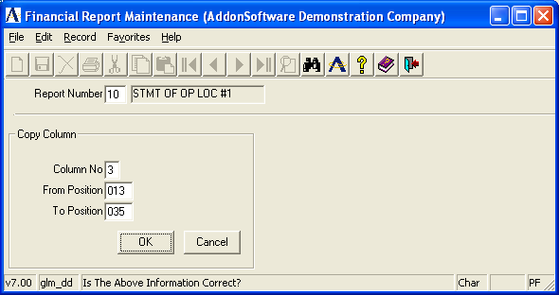

In the Column No field...
• Enter the number of the column, from 1-8, to be copied.
-or-
Press F4 to return to the Financial Report Maintenance options.

In the From Position field...
• Enter the current position of the column.

Only financial report lines with the specified From Position will be affected by the change.

In the To Position field...
• Enter the print position where you want the column to move.

In the Line No field...
Display only. Shows the line numbers of the data that is moved. A line will only be changed if the column print position is exactly the same as the line entered in the From Position field. After the column is moved, the cursor returns to the Column No Field.

Once you enter the 'To Position' information, the system issues the prompt:

Is The Above Information Correct?

• Enter Y if the information is correct and proceed with the move.
-or-
Enter N to make changes to the fields.
-or-
Press F4 to return to the Financial Report Maintenance options.

Financial Heading Maintenance
This task establishes standard report titles for the financial reports. This is the portion of the report reserved for information such as company name, report title, descriptions for column headings, dates included on the report, etc. Up to five lines may be formatted and each heading can be used on one or more financial reports. Refer to Appendix A, for a sample copy of the printed heading.

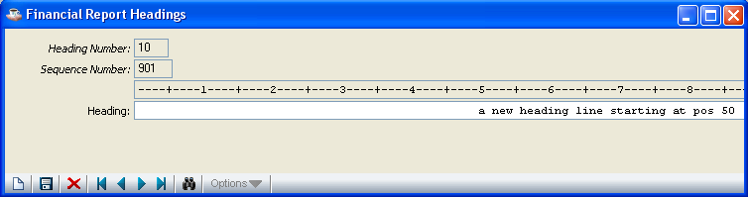

Information is entered using text editing. Five blank lines are displayed on the screen. Each line is numbered. Since the printer allows for 132 characters, the display is split into two parts, left and right.

The left sided display will show characters 1-70, the right sided display will show 66-132. Use the F1 key to toggle back and forth between the two sides. After entering text you can use F3 to center it. Refer to Entering/Editing Heading Text later in this section.

The information you enter can consist of actual text (e.g., Statement of Income and Expense), or codes for information added when the report is printed (e.g., [R-DATE] to print the run time date). The codes must be enclosed in brackets ([ ]) in order to be used. The following is a list of available codes, their meanings, and the format that will result on the report:

Code | Meaning/(Format)
C-YEAR | Current Year (20XX)
P-YEAR | Prior Year (20XX)
MONTH | Name of Current Month (January, etc.)
QUARTER | Current Quarter (First, etc.)
C-PERIOD | Current Period (Period XX From MM/DD/YY To MM/DD/YY)
P-PERIOD | Prior Period (Period XX From MM/DD/YY To MM/DD/YY)
C-END | Current Period Ending (Period Ending MM/DD/YY)
P-END | Prior Period Ending (Period Ending MM/DD/YY)
Y-END | Month and year (e.g. January, 20XX)
FIRM | (Company Name)
R-DATE | Report Run Date ( Run Date MM/DD/YY)
Column headings can be established for each of the eight columns printed on a report. Use the column headings positions specified in Detail Maintenance (page 70), as a guideline for positioning the column heading descriptions on the report.

In the Heading Number field...
• Enter the two-digit report number where this heading is to appear.
-or-
Press Return to accept the first number on file.
-or-
Press F4 to return to the Financial Report Maintenance Menu.

This field establishes a number assigned to the heading. If the number is already assigned, the information will be displayed and can be changed.

When you enter a number not assigned, the system issues the prompt:

Is This A New Record?

• Enter Y to access the Line # fields.
-or-
Enter N to return to the Heading Number field.

Whether you are assigning a new heading number or selecting an existing one, the system will display the known information. In the case of a newly assigned number, only the line spacing ruler will be displayed. The system will issue the prompt:

Is The Above Information Correct?

• Enter Y when the information is correct and to return to the Heading Number field.
-or-
Enter N if it is not correct or to create a new heading. Refer to Entering/Editing Heading Text, below.
-or-
Press F1 to toggle to the right/left side of the screen display.
-or-
Enter Print to print a sample of the report to use as a reference when adjusting spacing.
-or
Enter Delete to remove the heading from the file and return to the Heading Number field.
-or-
Press F4 to return to the Financial Report Maintenance Menu.

Entering/Editing Heading Text
When you select N at the Is The Above Information Correct? prompt, another prompt is issued:

Enter Optional Heading Information

• Enter any text to appear on the heading.
-or-
Press Return to access the next line.
-or-
Press F1 to toggle to the right/left side of the screen display. Since using this toggle involves two screens, each must be saved separately if changes have been made. Press Enter to reach the Is The Above Information Correct? prompt and approve the first screen, then come back into the same report. When you reach the correct line number, press F1 to toggle to the other side, make changes and repeat the save process.
-or-
Press F4 to access the Is The Above Information Correct? prompt again.

NOTE: Using F3 after text is entered, centers the line of text in the middle of the page. The F3 option to center text can only be used after the text is on the line. Press Enter to accept the data, and then use F2 to return to edit any line.

Account/Report Maintenance
This task links a general ledger account with up to ten different financial reports by specifying the report number and line. Similar to the Financial Statement Assignment task in Account Maintenance, this task is designed for the rapid assignment of information during Financial Report Maintenance.

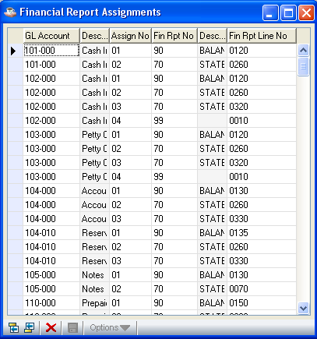

In the Account field...
• Enter the account number to be linked to a report.
-or-
Press F3 to select from a list of all valid account numbers.
-or-
Press F4 to return to the Financial Report Maintenance Menu.

Once an account number is selected, the description of that account is displayed on the screen along with the current reports it is linked with. The system will issue the prompt:

Is The Above Information Correct?

• Enter Y to accept the information and return to the Account field.
-or-
Enter N to make changes to the information.
-or-
Press F4 to return to the Financial Report Maintenance Menu.

In the Assignment Number field...
Display only. Shows the number of the assignment.

In the Report field...
• Enter a valid financial report number.
-or-
Press F3 to select from a list of all valid report numbers.

This field specifies which report is to be linked with this account. Up to ten report linkages can be specified for each account. The name of the report will be displayed.
Reports must first be defined in the Financial Report Maintenance task before accounts can be assigned to lines here.

In the Description field...
Display only. Shows the description of the linked report.

In the Line field...
• Enter a valid report line number. The report format listing is a useful tool for referencing line numbers.
-or-
Press F3 to select from a list of all valid line numbers.

This field specifies the line on the report linked to this account. The name of the line will be displayed.

When you have finished entering the information, press F4 to access the Is The Above Information Correct? prompt.

• Enter Y when the assignment is correct; the information will be updated to the file.
-or-
Enter N to make additional changes to the fields.
-or-
Press F4 to return to the Financial Report Maintenance Menu without updating.

Account/Report Cross-Reference Report
This task prints a listing of all account numbers on file as well as the financial reports and report lines assigned to them. This report can be used as a reference for further report development or for troubleshooting reports incorrectly set up. Refer to Appendix A, for a sample copy of the printed report.

Printing
As the report prints, account numbers are displayed on the screen to show its progress. The report prints in account number order and the account breaks defined in the General Ledger parameters are displayed. After printing, the Financial Report Maintenance Menu will be re-displayed.

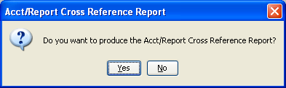

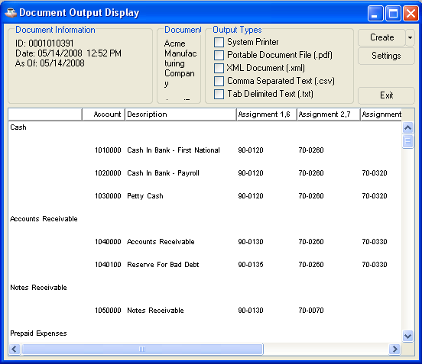

Total/Report Cross-Reference Report
This task shows where all total numbers are being used in reports. The printed report is useful for detecting and resolving financial report formatting problems involving numeric calculations. Refer to Appendix A, for a sample copy of the printed report.

The system issues the prompt:

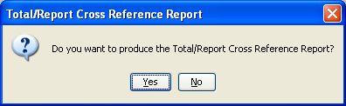
• Enter Y to print the report.
-or-
Enter N to return to the Financial Report Maintenance Menu.

Sorting
Before the report prints, the program reads through the detail lines of all financial reports to create a cross reference file.

Report/Account Maintenance
This task enables an automatic method of assigning several general ledger account numbers to a specific financial report line. As a result of this process, the specified financial report line collects the sum of each general ledger account linked to it.

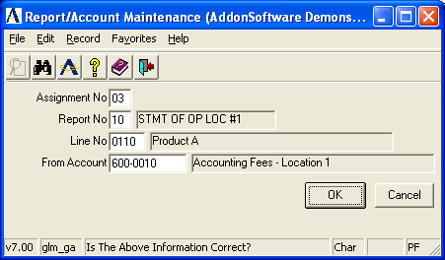

In the Assignment No field...
• Enter the assignment number, from 1 - 10. This field indicates which of the ten general ledger account financial report linkages are to be used for the automatic assignment.
-or-
Press F4 to return to the Financial Report Maintenance Menu.

In the Report No field...
• Enter a valid two-digit report number.
-or-
Press F3 to select from a list of all valid numbers.

This field defines the number of the financial report where specified accounts are to be linked. The description of the report will be displayed.

In the Line No field...
• Enter a valid line number from the report.
-or-
Press Return to select the next line number in sequential order.
-or-
Press F3 to select from a list of all valid numbers.

This field specifies the line number on the financial report where the general ledger accounts are to be linked. The line description will be displayed. Only detail lines defined in the Financial Report Maintenance task and assigned in the Account/Report Maintenance task are valid.

In the From Account field...
• Enter the first account number to be assigned to this report.

This field indicates the beginning general ledger account in a range of accounts assigned to this report and line number. When assigning a range of accounts with similar numbers, enter as many numbers as are common to all account numbers. Enter a ? in any position of the account that you want to ignore or that is a variable number.

NOTE: Do not enter dashes (-) as part of the general ledger number, even though the general ledger account mask includes them.

Account Range Example
Assign this report/line to all accounts ending in 15. If your account number had 5 digits (omitting dashes), you would enter ???15.

The system will issue the prompt:

Is The Above Information Correct?

• Enter Y to automatically assign the account to a specific report line.
-or-
Enter N to make changes to the fields.
-or-
Press F4 to return to the Financial Report Maintenance Menu.

Updating
As the accounts are updated to the report, general ledger account numbers display to show the progress. Following the update the cursor will return to the From Account field. Enter F2 to backup to the Line No field and select another report line number.

Consolidated Account/Report Maintenance
This task allows for rapid assignment of general ledger accounts to consolidated financial reports. Each account can be assigned to up to ten different consolidated reports. The consolidated reports must be defined within company 99. Refer to Producing Multiple Company Consolidated Reports in Appendix D for information on how to define consolidated financial reports.

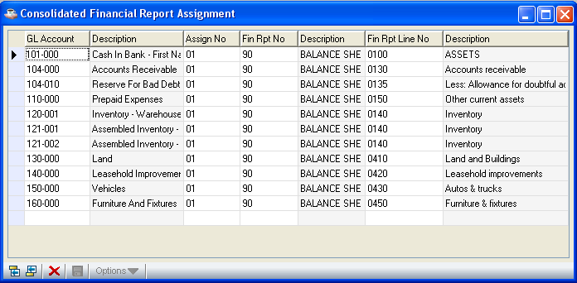

In the Account No field...
• Enter a valid general account number.
-or-
Press Return to move through the accounts sequentially.
-or-
Press F3 to select from a list of all valid account numbers.
-or-
Press F4 to return to the Financial Report Maintenance Menu.

This field indicates the general ledger account number to be linked to consolidated reports. After selecting an account, the description and account type will be displayed on the screen.

The system will issue the prompt:

Is The Above Information Correct?

• Enter Y when the report information is correct and to update the file. You will be returned to the Account No field.
-or-
Enter N to access the fields.
-or-
Press F4 to return to the Financial Report Maintenance Menu.

In the Assignment Number field...
Display only. Shows the number of the assignment.

This field indicates which of the ten financial report linkages are to be used for the automatic assignment.

In the Report field...
• Enter a valid report number.
-or-
Press F3 to select from a list of all valid reports.

This column indicates the consolidated financial report where this account is to be linked. Each account may be linked directly to ten financial reports, if required.

In the Description field...
Display only. A description of the selected report as defined in Detail Maintenance is shown.

In the Line field...
• Enter a valid line number.
-or-
Press F3 to select from a list of all valid line numbers.

This column indicates the line on the consolidated report where this account is to be linked. A line number should be entered for each report listed.

In the Description field...
Display only. A description of the selected line as defined in Detail Maintenance is shown.

Press Return through the fields or F4 from any field when you have finished viewing or entering consolidated information. The system will issue the Is The Above Information Correct? prompt to update the files.

Consolidated Account/Report Cross-Reference Report
This task prints a listing of all general ledger account numbers on file and the consolidated financial reports and report lines where they are assigned. The report is organized by account breaks and can be used as a reference for further report development or for troubleshooting reports that were setup incorrectly. Refer to Appendix A, for a sample copy of the printed report.

Printing
As the report prints, account break descriptions are displayed on the screen to show its progress. After printing, you will be returned to the Financial Report Maintenance Menu.

Create Departmental Reports
This task provides a way to automatically define the format of financial reports from the general ledger chart of accounts, and to establish the linkage from the accounts to the financial report detail lines.

The Create Departmental Reports task is useful for quickly creating financial report detail lines using the general ledger account descriptions. The detail line descriptions may then be modified using the Financial Report Maintenance task. Ranges of general ledger account numbers, as well as department number selections, can be made to selectively construct the detail lines of the report format.

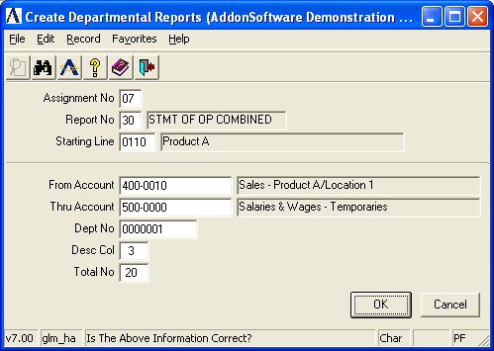

NOTE: When creating a financial report format, the report creation process can be run several times in sequence to include various ranges of general ledger accounts with various department numbers. Be sure to keep track of the report line numbers that are generated, as well as the general ledger account linkages assigned to avoid any conflicts or overwriting of data.

In the Assignment No field...
• Enter an assignment number from 1-10.
-or-
Press F4 to return to the Financial Report Maintenance Menu.

This field specifies which of the ten general ledger account linkage assignments to use for the financial report linkage.

NOTE: Be sure that you do not select an assignment number currently in use. Otherwise, the new linkage information will replace the previous linkage information.

In the Report No field...
• Enter a valid report number. A description of the report will be displayed.
-or-
Press F3 to select from a list of all valid report numbers.

This field indicates the number of the financial report where the selected general ledger accounts are to be linked when the report is automatically created.

In the Starting Line field...
• Enter a new line number.
-or-
Press F3 to determine existing line numbers.

NOTE: Be sure that the starting line number, along with others that will be created, do not conflict with line numbers already existing for the selected report. Otherwise, the original lines within the report will be lost.

This field indicates the first line number used in creating the financial report detail lines. As the report detail lines are created during the update, each successive line number will be incremented by 10.

In the From Account field...
• Enter a valid general ledger account number.
-or-
Press F3 to select from a list of all valid account numbers.

This field indicates the first general ledger account number included on the financial report. The detail lines created as part of the financial report format will use the descriptions from the general ledger accounts that are selected.

In the Thru Account field...
• Enter a valid general ledger account number.
-or-
Press F3 to select from a list of all valid account numbers.

This field indicates the last general ledger account number included on the financial report.

In the Dept No field...
• Enter a number representing a department number for the selected accounts.
-or-
Press Return to select all departments of the selected accounts.

This field allows you to selectively include general ledger account numbers based on the trailing digits of an account if they represent some type of division of the profit and loss accounts. Financial report formats for selected departments, profit centers, locations, etc. can automatically be created.

Department Number Example
When the last two digits of the account number are used to designate a department number, and you want to create a financial report that only includes accounts for Department 12, enter 12.

NOTE: If the chart of accounts is organized in such a way that the departmentalization is not represented by the trailing digits of an account number, you can still create departmental reports by entering the report linkages manually.

In the Desc Col field...
• Enter a valid number between 1 and 131.

This field indicates the column number where the account description is to be printed on the report format. Make sure that the description does not extend beyond position 131 or else an error may occur during printing of the report.

In the Total No field...
• Enter the total number to which each detail line should be accumulated.

To create multiple totals within the report format, either run the report creation process more than once, or use the Financial Report Maintenance task to enter the exact arrangement of totaling required.

The system issues the prompt:

Is The Above Information Correct?

• Enter Y to proceed with the creation of the financial report format.
-or-
Enter N to make changes to the fields.
-or-
Press F4 to return to the Financial Report Maintenance Menu.

Updating
As each financial report line is created, its report line number and line description is displayed. The financial report detail lines are created using the description of the general ledger accounts. The line numbers of the detail lines are incremented by 10, and the general ledger accounts are automatically linked to the report and line number specified.

Copy Financial Reports
With this task, you can copy the format of one financial report to another. It provides an efficient means of rapidly duplicating financial report formats within a single company or between separate companies.

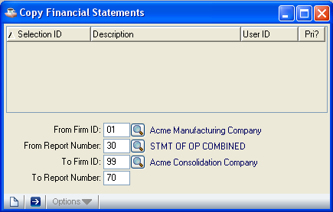

In the From Company field...
• Enter the company number originally defined for the report.
-or-
Press F3 to select from a list of all valid company numbers.
-or-
Press F4 to return to the Financial Report Maintenance Menu.

This field indicates the source company of the financial report format to be copied.

In the From Report Number field...
• Enter a two-digit report number.
-or-
Press F3 to select from a list of all valid report numbers.

This field indicates the financial report number to be copied.

In the To Company field...
• Enter the company number to which the report will be copied.
-or
Press F3 to select from a list of all valid company numbers.

To the Report Number field...
• Enter a two-digit report number.
-or-
Press F3 to select from a list of all valid report numbers.

This field indicates the report number to be assigned to the copied report.

WARNING: If the report number entered in the To Report Number field already exists, it will be overwritten by the information from the source report.

The system issues the prompt:

Is The Above Information Correct?

• Enter Y if the information is correct; the new report will be created.
-or-
Enter N to make changes to the fields.
-or-
Press F4 to return to the Financial Report Maintenance Menu without copying the report.

Copying
As each line is copied from the existing report to the new report, the detail line numbers are displayed on the screen.

Financial Report Printing
This is the same report task that is accessible from the General Ledger Reports Menu in the Financial Report Printing task. Refer to Appendix A, for sample copies of the printed reports.

13 Period Financial Report Printing
This is the same report that is accessible from the General Ledger Reports Menu. Refer to the earlier 13 Period Financial Report section for a description of this task. Refer to Appendix A, for a sample copy of the printed report.

Period End Processing
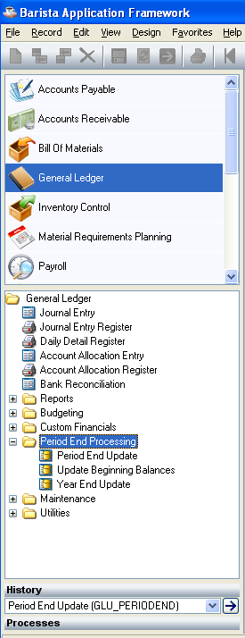
GL Period End Processing Menu

Function
This menu accesses the tasks used in closing the accounting period. The Journal Entry Register, Daily Detail Register, and Account Allocation Register must be updated before running the period end process. Period end processing for all subsidiary ledgers interfacing to the General Ledger should be completed before the period end processing is performed for the General Ledger.

n To access this task...

Select Period End Processing from the General Ledger Main Menu.

Period End Update
This task closes the selected general ledger period. It should only be run after all subsidiary ledger period end processes are run. If the current period is being closed, then the GL period is advanced by one. The closed period is then locked. Closing prior periods has no effect other than to lock the period. Future periods may not be closed.

If the period being closed is the last period in the fiscal year, then the period is set to one, the current fiscal year is incremented by one, and the Fiscal Year Closed flag is set to ‘N’. This allows you to continue processing into the next fiscal year while making final adjustments to the last period of the year being closed. A fiscal year may not be closed if the prior fiscal year is still open.

In the Period field...
• Enter the accounting period to be closed.

In the Year field...
• Enter the fiscal year for the period to be closed.

.

If you not run Journal Entry Register and updated, the module issues the prompt:

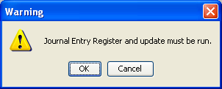

Update Beginning Balances
This task is run after the period end update for the last period in a year and prior to the closing of the fiscal year. Use this task to bring balances forward into the current year for balance sheet accounts. The Update Beginning Balances can be run as frequently as necessary to indicate any changes.

Retained earnings will be calculated. Income and expense account balances will be accumulated, and the difference between income and expense will be posted to the retained earnings account specified in the parameters. The ending balances for Asset, Liability, and Capital accounts will become beginning balances for the new year. Income and expense account balances will be set to zero. The Update Beginning Balances Register is also produced. Refer to Appendix A, for a sample copy of the printed report.

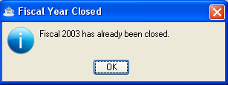

- Click OK or the Close Window button to return to the Update Beginning Balance Processing.

Printing
As the report prints, the general ledger account numbers are displayed on the screen to show its progress.

Once the printing is completed, another prompt is issued:

Are You Ready to Update the Account Beginning Balances?

• Enter Yes when you want to post the results of the Beginning Balances Register to the next period.
-or-
Enter No to return to the Period End Processing Menu without updating.
-or-
Press F4 to return to the Period End Processing Menu.

Year End Update
During the Year End Update, current year actual and budget figures for each general ledger account are moved to the prior year history file; next year actual and budget figures are moved to current year. Income and expense account balances will be accumulated, and the difference between income and expense will be posted to the retained earnings account specified in the parameters. The ending balances for Asset, Liability, and Capital accounts will become beginning balances for the new year. Income and expense account balances will be set to zero. The Year End Update Register is automatically produced.

NOTE: The period-end process for the last fiscal period of the year should be completed first for all subsidiary accounting modules before closing the year for the general ledger. If Payroll is installed, it has a separate year-end update task to be performed after the last payroll of the fiscal year.

If you not run the Journal entry form successfully and not updated it, the module issues the prompt:
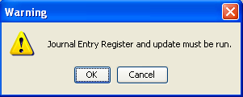

Updating
As the update progresses, general ledger account numbers display on the screen to show the progress.

General Ledger Maintenance
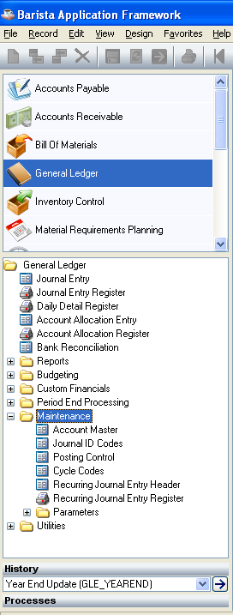
General Ledger Maintenance Menu

Function
This menu allows access to the tasks used to maintain the General Ledger module. Through these tasks general ledger accounts can be maintained, journal codes and recurring journal entries can be entered, parameters can be established, and the Account Maintenance option menu can be accessed.

n To access this task...

Select Maintenance Menu from the General Ledger Main Menu.

.

About the Account Master Menu
The Account Master Menu displays the GL Account, Description, Acct Type, Detail of all the GL Accounts in a window. You can view the account information, make changes to the account, or add and delete information by selecting available options from the window. Using these options you can access to the different processes associated with keeping an account up to date

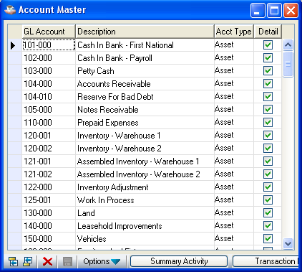

Field descriptions for the Account Master menu are as follows.

In the GL Account column field...
• Enter a valid GL account number.

If you enter a number for an account to be defined, the system issues the prompt:

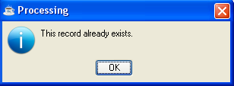

- Click OK or the Close Window button to return to the Update Beginning Balance Processing.

In the Description column field...
• Enter a description for the account of up to 35 characters.

The description will appear on all reports and inquiries showing accounts and their descriptions.

In the Acct Type column field...
•

Select the Account Type from the Dropdown List

In the Detail checkbox field...
• Checked to post detail information to this account (i.e. with each individual debit or credit transaction posted).

- Unchecked to post only summary information to this account (i.e. summarized by journal ID and date).

NOTE: Checkbox defaults to Unchecked unless the Post Detail Transactions parameter is set to Checked in the Application Parameters window in Parameters menu.

NOTE: Active accounts (those with open transactions) may not be deleted. To delete an account, its balance must be brought to zero and all transactions cleared through the Purge GL Transaction History task.

When you have selected the desired option,

Click Add to end to add a new GL Account after the last current row.

Click Insert before to insert a new GL Account before the currently selected row.

Click Delete to deletes the current GL Account, you selected. Note: Clicking the delete button will delete the GL Account you selected and its associated records. A confirmation message box will be issued in this event.

Click Save to save the GL Account in the current row you selected.

Click Options to dropdown menu containing optional processes, such as subsidiary forms or reports.
- Click OK the Close Window button to return to the Account Master

Summary Activity
For getting this option click on the ‘Summary Activity’ button of the current form or select ‘Summary Activity’ option from the Options

This option provides a summarized display of account activity by period, along with beginning and ending balances. The columns displayed are determined by the Default Display Columns option of the Maintenance → Parameters menu. Only budget information can be changed.

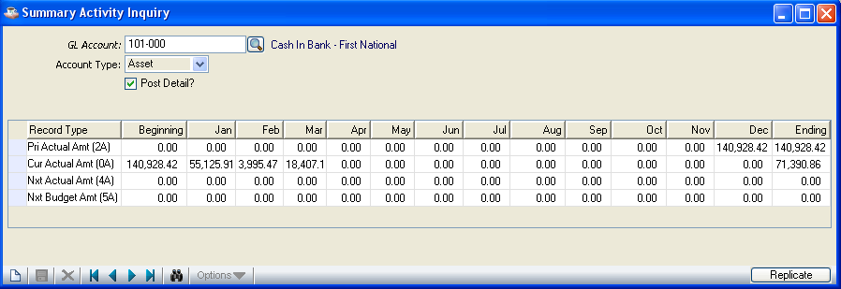

In the GL Account field...
- Display only. Shows the number of the account used in maintenance.
- Click the Find button to select from a list of existing type codes associated with this GL Account and it displays a window as shown below which contains the GL Account, Description, Acct Type and Detail.
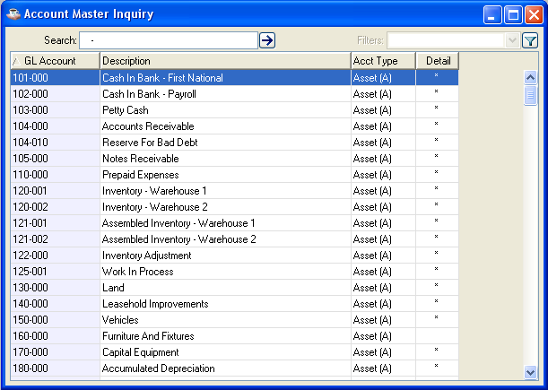

In the Account Type field...
Display only. Shows the account type as determined in Account Master and display other Account Types in a drop down menu

In the Post Detail? field...
Display only. Shows the detail as determined in Account Master. Checkbox field indicates the detail is posted or not.

Transaction History
For getting this option click on the ‘Transaction History’ button of the current form or select ‘Summary Activity’ option from the Options

This option will display any transactions (that have not been purged) for a selected general ledger account during a specified range of accounting periods. Once you have entered the search parameters for the transactions, a display screen appears with the results showing the transaction period, the date, reference information, audit number, and the transaction amounts.

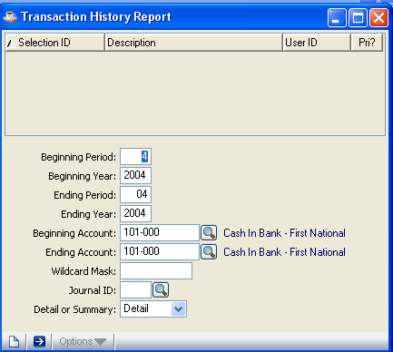

r.
When you first access this task, you will be presented with an Option Entry screen:

In the Beginning Period…
- Enter the month of the beginning period you want shown on the inquiry.

In the Beginning Year…
- Enter the year of the beginning period you want shown on the inquiry.

In the Ending Period…
- Enter the month of the ending period you want shown on the inquiry.

In the Ending Year…
- Enter the year of the ending period you want shown on the inquiry.

In the Beginning Account field…
- Enter the beginning account number you want shown on the inquiry.
- Click the Find button to select from a list of existing type GL Account codes

In the Ending Account field…
- Enter the ending account number you want shown on the inquiry.
- Click the Find button to select from a list of existing type GL Account codes

In the Account Wildcard Mask field…
- Enter the wildcard mask to be used in selecting from the above accounts.

In the Journal ID Code field...
• Enter any Journal ID to include on the report.
- Click the Find button to select from a list of existing type Journal ID codes

In the Detail or Summary field...
• Select Detail from the dropdown list to display the transactions in detailed format.

- Select Summary from the dropdown list to display the transactions in summarized format by journal ID and date.

When you Click the Run Process button to accept the selections and the transactions matching your criteria are appeared in a Document Output Display window .

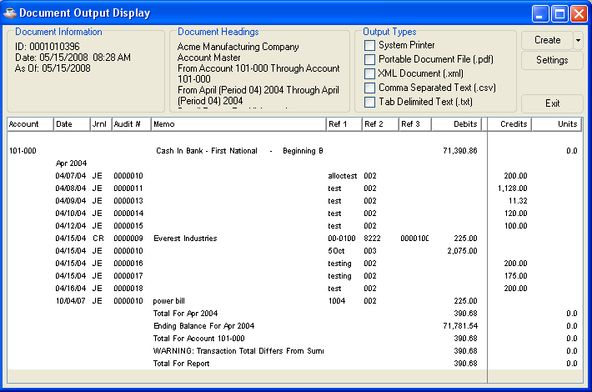

Any data shaded with pink in the Document Output window is at risk of truncation when the document is printed or saved in pdf format. Click and drag to adjust column sizes until no pink shading remains. If the report is too large to adjust in this manner, save it in one of the disk file formats (xml, csv, txt) in order to prevent data loss.

Choose your Output Type and click the Create button. After the file is created or printed, click the close icon or press ctl-F4 to close the Document Output Display window.

The following information appears in the Transaction History Inquiry detailed display:

Account
GL Account number which was selected from the Account Master Window. Here you got the corresponding information of this Account number.

Date
The date the transaction was posted to the general ledger. It normally will fall within the date range of the selected periods, though postings with a prior date may also be included if they were posted during the selected period.

Journal
This column displays the two-digit journal ID associated with this transaction.

Audit #
The number is generated and appears on the register creating this transaction.

Memo
This line displays the description of the transaction as entered in the Account No./Memo field as part of a journal entry (if applicable) or a memo generated automatically by a subsidiary module interfaced to the General Ledger. The line is directly below the Journal ID description.

Ref1, Ref2, Ref3
This line displays the referencing numbers of this account and is directly below the Memo description. Each transaction can have three 10-character references assigned to them.

Debits
This column displays the total number of debits associated with this transaction

Credits
This column displays the total number of credits associated with this transaction

Units
This column displays the total number of units associated with this transaction. This column will only appear if the Use Units? parameter was set to checked in the ‘Application Parameters’ in Parameters option from Maintenance→ Parameters menu.

NOTE: Refer to the Installation section for a complete explanation of how the Unit Mask may be set up.

A summarized display of the transactions shows everything. The amount and units are totaled for all transactions with the same journal ID and date.

Account Comments
Account Comments allows for the creation, modification, deletion, and inquiry, of account comments.

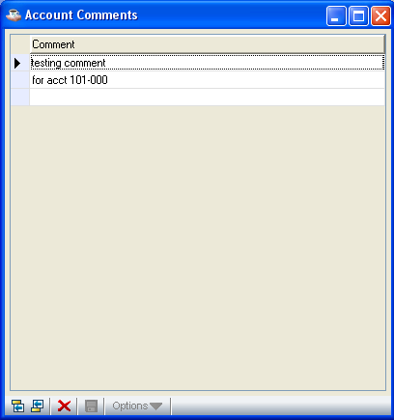

For modification a comment
1. Press Return to access the selected comment.
2. Type over original comment.

In the Comment field...
• Enter any comment of up to 48 characters in length.

When you have selected the desired option,

Click Add to end to add a new comment after the last current row.

Click Insert before to insert a new comment before the currently selected row.

Click Delete to deletes current comment in the line you selected.

Financial Report Assignments
This option links the selected account with as many as ten financial reports. Each link is established by specifying the report and line number where this account is to be reported..

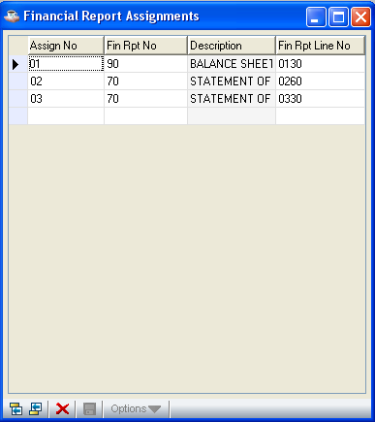

Journal ID Codes
This task allows for the addition, modification, inquiry and deletion of journal identification codes and their descriptions. A printed copy of the codes can be requested. Refer to Appendix A, for a sample copy of the printed list.

Journal ID codes are required when making journal entries, and used by the subsidiary accounting applications to make automatic postings to the General Ledger. On the Daily Detail Register, all postings with the same date are grouped by journal ID code. The Transaction History Inquiry and/or Report also summarizes all postings for the period using this code.

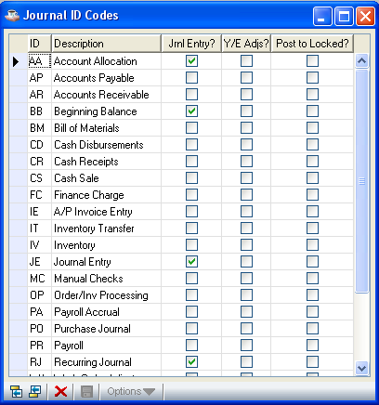

In the ID column...
• Enter a two character alphanumeric code to identify a type of journal transaction.

In the Description column...
• Enter a description for the journal ID code of up to twenty characters in length.

In the Jrnl Entry? column...
• Check the Jrnl Entry? checkbox to allow journal entries to be made using this ID.

- Uncheck the Jrnl Entry? checkbox to prevent journal entries from being made using this ID.

This feature is helpful in controlling the source of postings made to the general ledger through the Journal Entry task. It is generally recommended that Journal IDs used for postings from subledgers not be used for journal entries.

In the Y/E Adjs? column...
• Check the Y/E Adjs? checkbox to permit year end adjusting entries with this ID.

- Uncheck the ‘Y/E Adjs? checkbox to prevent year end adjusting entries with this ID.

Year end adjustments can only be made using the Journal Entry task. It is generally recommended that one or two specific ID codes be reserved for that purpose, and the others set to uncheck the checkbox in this field.

In the Post To Locked? column...
• Checked the Post To Locked? checkbox to allow posting of entries with this ID to locked periods.

- Unselect the Post To Locked? checkbox to prevent posting of entries with this ID to locked periods.

While in the detail grid, use the Enter key to toggle between navigation mode and edit mode in a given cell. In navigation mode, the cell has a dotted outline. In edit mode, the contents of the cell are selected.

While in edit mode
• Use the Enter key to accept the edits and remain in the cell, toggling to navigation mode
- Use the Tab key to accept the edits and move to the next cell

While in navigation mode
- Use the Enter key to highlight the contents of the cell and perform edits (i.e., toggles to edit mode)
- Use the arrow or tab keys to move to different cells

In either edit or navigation mode
  - Use the F7 key to toggle between the header and detail grid portions of the form

- Click the Delete button to delete the current line Note: No confirmation message box will be issued in this event.

- Click the Save button to save the current records
- Click the Close Window button to return to the Maintenance

Posting Control
This task defines the parameters controlling the interface between various programs and the General Ledger. An entry must exist for each program in the system posting to the General Ledger. It can be used to define the level of detail captured by the transactions. It can also be used to display when a register was last run.

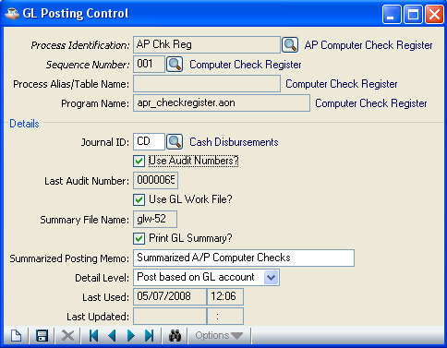

The majority of the information within this task is provided by AddonSoftware with the module and may be tailored during installation by your dealer. Use this task to review the Journal ID being used, the default memo for summarized postings, and the last date and time it was run. A printed list of all program names and information is available. Refer to Appendix A, for a sample copy of the printed list.

NOTE: Posting Control Maintenance is usually accessed only during the set up of the module. Additional information on each of the General Ledger programs is provided in the Installation section of the manual. Consult your dealer before attempting to make any changes to the programs.

In the Process Identification field…
- Enter a valid process ID

- Click the Find button to select from a list of valid process IDs.

In the Sequence Number field
- Enter a valid sequence number
- Press the Find button to select from a list of valid sequence numbers.

When you select a sequence number, Process Identification, Sequence Number, Process Alias/Table Name, Program Name, Use Audit Numbers?, Use GL Work File?, Summary File Name, Last used, Last Updated are disabled. These are displayed only according to the sequence number you given.

In the Process Alias/Table Name
Displays if any process alias/table name exist according to the process number and sequence number you given.

In the Program Name field...
Displays the program name according to the process number and sequence number you given.

In the Journal ID field...
• Enter any Journal ID code.

- Press the Find button to select from a list of all valid IDs.

This code will be used for all transactions generated from this program.

In the Use Audit Numbers? field...
Display only. Shows the option selected during installation of the module.

This field indicates whether batched transactions generated by the program should be identified with a unique audit control number assigned by the module. Normally, this checkbox field is set to unchecked for entry programs (not posting directly to GL) and to checked for the associated register/update programs (that do).

In the Last Audit Number field...
Display only. Shows the last audit number used by this program.

In the Use GL Work File field...
Display only.

Shows the option selected during installation of the module.

This field indicates whether the program uses a summary work file for accumulating transaction information. The information is then used in the optional printing of general ledger transaction summaries on reports from modules that post to the General Ledger. Normally, this field is set to unchecked for entry programs (not posting directly to G/L) and checked for the associated register/update programs (that do). This field must be set to checked if the Print G/L Summary field is set to checked.

In the Summary File Name field...
Display only. Shows the file name.

In the Print G/L Summary? field...
• Check the ‘Print G/L Summary?’ checkbox to print GL Summary. Uncheck the ‘Print G/L Summary?’ checkbox if you don’t want to print the GL Summary.

In the Summarized Posting Memo field...
• Enter the memo to be used as the default summarized posting. This will be the only description used when posting a summarized transaction.

In the Detail Level field...
• Post detail transactions to post a general ledger transaction for each subledger transaction. For instance, each invoice, check, receipt, etc., will write at least two general ledger transactions.

- Post summary transactions to summarize postings for each date within a register.

- Post based on GL Account to post in detail or summary based on the Detail? flag on the account.

In the Last Used field...
Display only. Shows the date that this register was last run.

In the Last Updated field...
Display only. Shows the date that this register was last updated.

- Click the Delete button to delete the current record
- Click the Save button to save the details. The form is cleared in preparation for a new entry.
- Click the New button to begin a new invoice entry
- Click the Close Window button to return to the Maintenance Menu.

If you attempt to leave an unsaved invoice by clicking New or Close Window, the module will issue a confirmation box as follows:

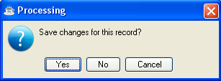
- Click Yes to save the current record and return to Maintenance Menu.

- Click No to return to the Maintenance Menu without saving the current record.
- Click Cancel or the Close Window button to return to the GL Posting control screen.

Cycle Code Maintenance
Use this task to create, maintain, or modify cycle codes. Cycle codes are used in recurring journal entries to allow you to select specific transactions. Codes can be assigned any period length of your choosing. A printed list of all codes is available. Refer to Appendix A, for a sample copy of the printed list.

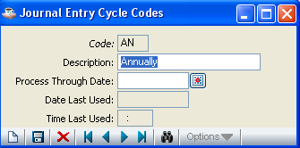

In the Cycle Code field...
• Enter a two character code.

- Press Record Query button to select from a list of all valid codes.

When you enter a code already defined, the description and entry type will appear. It may then be changed, if necessary. The system issues the prompt:

- Click Yes to save the current record and return to Maintenance Menu.
- Click No to return to the Maintenance Menu without saving the current record.
- Click Cancel or the Close Window button to return to the ‘Cycle Codes’ screen.

In the Description field...
• Enter a description of the code up to 20-characters in length.

In the Process Through Date field...
• Enter the last date that this code should be used. This can be used to limit the use of a recurring journal entry to a limited period of time.
- Click the Calendar button to select a date by using the calendar tool.

In the Date Last Used field...
Display only. Shows the date when this code was last used.

In the Time Last Used field...
Display only. Shows the time when this code was last used.

The system issues the prompt:

- Click Yes to save the current record and return to Maintenance Menu.
- Click No to return to the Maintenance Menu without saving the current record.
- Click Cancel or the Close Window button to return to the ‘Cycle Codes’ screen.

Recurring Journal Entry Header
This task is used to create and maintain general ledger journal entries required on a recurring basis (e.g., rent, depreciation schedules, etc.). The recurring journal entry header is transferred to the Journal Entry task following printing of the Recurring Journal Entry Register.

NOTE: Recurring Journal Entries are entered using the same format as regular Journal Entries. Please refer to that section for additional information.

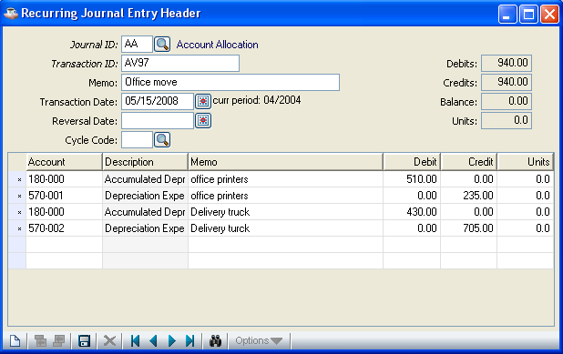

In the Journal ID field...
• Enter a valid two character Journal ID code (e.g., JE for Journal Entry).
- Press the Find field records button to select from a list of all valid codes

Each Journal ID code must already be defined and set up through the Journal ID Codes task in the Maintenance menu to allow entries to be made using the code.

If the Journal ID is empty the system issues a message box:

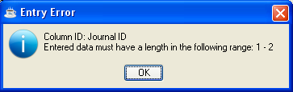

If you enter a new Journal ID code the system issues a message box:

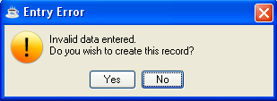

- Click Yes to create a new record.
- Click No to return to the Maintenance Menu without creating the record.

In the Transaction ID field...
• Enter a transaction ID for this journal entry of up to 10 characters long.

In the Memo field...
This field is optional.
• Enter a description up to 30 characters long.

This field helps describe the overall purpose of the journal entry and will print on the Recurring Journal Entry Register and Daily Detail Register. This description does not carry into the general ledger after updating (Refer to Account/Memo field).

Memo Example
Inventory Adjustment

In the Transaction Date field...
• Enter the date in the MMDDYY format.
- Click the Calendar button to select a date by using the calendar tool.

NOTE: The actual month and year of this entry will change, and will be requested before it is updated to the Journal Entry task.

In the Reversal Date field...
This field is optional.
• Enter a date for this transaction to be reversed.

- Click the Calendar button to select a date by using the calendar tool.

Use this field when you want to automatically have this transaction reversed on the specified date. When a reversal date is entered, a second journal transaction is automatically created, appears on the general ledger daily report, and will automatically update to the general ledger as an exact reversal of the first entry.

In the Cycle Code field...
This field is optional.
• Enter the cycle code assigned to this recurring journal entry.

- Press the Find field records button to select from a list of all valid codes.

The system will issue the prompt when we click on the close button of the window

Click Yes to save the current record and return to Maintenance Menu.
- Click No to return to the Maintenance Menu without saving the current record.
- Click Cancel or the Close Window button to return to the ‘Recurring Journal Entry Header’ screen.

In the Debits field...
Display only. Shows the total debits for this journal entry.

In the Credits field...
Display only. Shows the total credits for this journal entry.

In the Balance field...
Display only. Shows the balance for this journal entry.

In the Units field...
Display only. Shows the units for this journal entry.

Line Detail Entry
The body of each recurring journal entry consists of detail debit and credit lines where each line contains the following information:

In the Account field...
• Enter a valid GL account number. The description of the account will be displayed.

If you enter not a valid GL account the system will issue the prompt

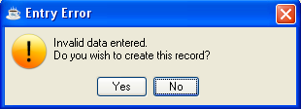

- Click No to return to the Maintenance Menu without creating the record.
- Click Yes to displays a window for creating a new record

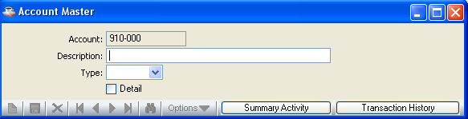

- Account field contains the Journal ID you entered. Displays only.
- Enter a description for this new account
- Select the type of Account (Asset, Liability, Capital, Income and Expense) from the type.

In the Memo field…
This field is optional.
• Enter a memo of up to 30 characters to further identify each line item of the journal entry.

This memo will appear on the Journal Entry Register, Daily Detail Report and be carried into the Detail Transaction File in the general ledger.

In the Debit field...
• Enter the debit amount for this recurring journal entry.
- Use the Tab key to accept the edits and move to the Debit field.

In the Credit field...
• Enter the credit amount for this recurring journal entry.
- Use the Tab key to accept the edits and move to the Units field.

In the Units field...
This field is optional.
• Enter the number of units for this account.

This field only enabled if the Units parameter is set to Yes in the General Ledger Parameter Maintenance task.

Units Example
You could enter 7 if the transaction involved renewal of 7 vehicle licenses.

Recurring Journal Entry Register
This task prints a listing of all recurring journal entries by cycle code and then updates them to the Journal Entry file. A specific cycle code may be selected. Once updated, these entries are then processed as any other journal entry. The Recurring Journal Register includes all information entered in Recurring Journal Entry. Refer to Appendix A, for a sample copy of the printed register.

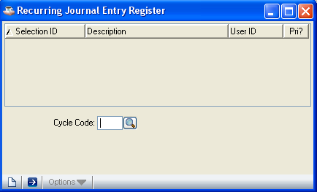

• Select the Run Process button to print the register.

In the Cycle Code field...
• Enter the selected cycle code for the register.

- Click the Find button to select from a list of all valid codes.

Cycle codes enable you to print and update only those entries that have the same cycle code.

If you enter a new cycle code
the system will issue the prompt:

- Click No to return back to the previous window.

• Click Yes to create the new cycle code. Cycle Codes window will be displayed for the new record.

- 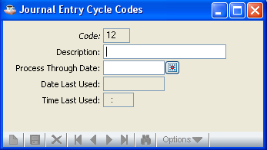

- Code field - contains the Cycle Code you entered. Displays only.
- Description field - Enter a description for this Cycle Code
- Process Through Date - Enter the last date that this code should be used. This can be used to limit the use of a recurring journal entry to a limited period of time.
- Click the Calendar button to select a date by using the calendar tool.
- Date Last Used - Display only. Shows the date when this code was last used.
- Time Last Used - Display only. Shows the time when this code was last used.

Printing
As the report prints, the journal ID numbers are displayed to show its progress. When the print information has been sent the module will issue a confirmation box as follows:

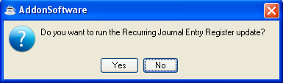
• Click Yes to proceed with the update as printed.

- Click No to bypass the update and return to the Maintenance Menu. To correct any errors, use the Recurring Journal Entry task.

Note: The date from the original Recurring Journal also appears on this report.

The Recurring Journal Entry Register will appear in the Document Output Display window. Select your desired output format and click the Create button:

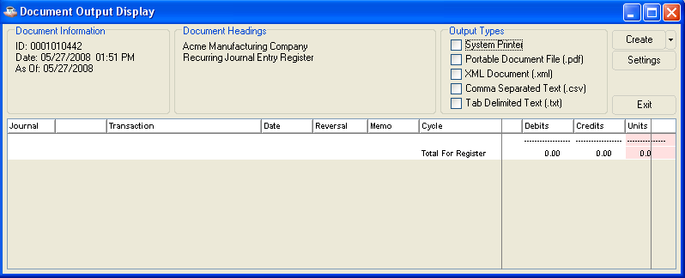

Any data shaded with pink in the Document Output window is at risk of truncation when the document is printed or saved in pdf format. Click and drag to adjust column sizes until no pink shading remains. If the report is too large to adjust in this manner, save it in one of the disk file formats (xml, csv, txt) in order to prevent data loss.

Choose your Output Type and click the Create button. After the file is created or printed, click the Close Window button or press ctl-F4 to close the Document Output Display window.

Updating
As the information is updated, journal entry transaction numbers are displayed to show its progress.

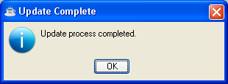

Parameters
The Parameters menu allows you to add, change, view, and delete general ledger parameter information. An option menu allows access to the four parameter options. These options help establish general ledger parameters, define periods and specify chart of account breaks and default display columns.

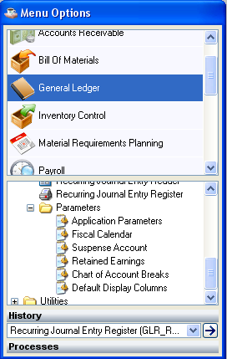
Parameters menu

NOTE: Parameter Maintenance is usually accessed only during the set up of the module. Additional information on each of the General Ledger parameters is provided in the Installation section of the manual. Consult your dealer before attempting to make any changes to the parameters.

Application Parameters
This screen establishes and maintains the standard parameters of your General Ledger module. The options to retain detail transactions, use budgets, use units, and specify a posting method are also established here.

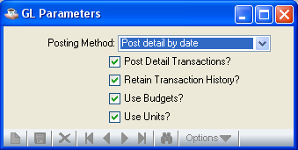

In the Posting Method field...
Click the ‘Posting Method’ drop down menu for selecting your posting method.

In the Post Detail Transactions field...
• Check the Post Detail Transactions? checkbox when individual modules transfer detail postings to the General Ledger.

- Uncheck the Post Detail Transactions? checkbox when transactions are summarized into one entry.

This field specifies whether all postings from the subsidiary ledger are to be posted in summary or posted in detail. For most companies, detailed postings will be standard.

NOTE: This flag, when set to summary, will override the Detail Transaction flags in the Posting Control task and the Account Masterfile.

In the Retain Transaction History field...
• Check the Retain Transaction History? checkbox to retain detail transactions after the Daily Detail Update.

- Uncheck the Retain Transaction History? checkbox to discard detail transactions after the update.

This flag is used to generate daily detail posting that may be transferred to another system.

NOTE: When this flag is set to ‘N’ there will be no transaction history.

In the Use Budgets field...
• Check the Use Budgets? checkbox when budget information is to be maintained and included on reports and inquiries.

- Uncheck the Use Budgets? checkbox if budget information will not be used.

In the Use Units field...
• Check the Use Units? checkbox when unit information is to be maintained and included on reports.

- Uncheck the Use Units? checkbox if unit information will not be used.

- Click the Save button to save the details.
- Click the Close Window button to return to the Parameters Menu.

If you attempt to leave an unsaved ‘Application parameters‘ by Close Window, the module will issue a confirmation box as follows:

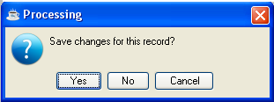

• Click Yes to save the current record and return to Parameters Menu.
- Click No to return to the Parameters Menu without saving the current record..
- Click Cancel or the Close Window button to return to the current Application Parameters Screen

Fiscal Calendar
This option displays the accounting periods defined for the fiscal year within System Maintenance. Accounting periods are used throughout the General Ledger module, and are defined by the ending date that is set up for each period. This option allows you to change the Locked? flag.

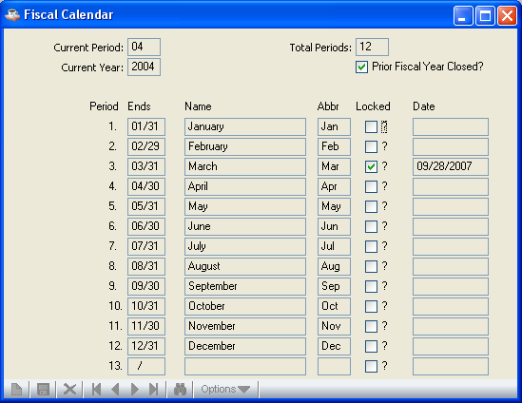

In the Current Period field...
• Display only.
.

In the Current Year field...
• Display only.

In the Prior Fiscal Year Closed field...
Display only. Shows whether the previous fiscal year has been closed.

In the Total Periods field...
Display only. Shows how many periods were set up in the Fiscal Calendar Maintenance task of the System Maintenance menu.

In the Period field...
Display only. Shows the number of the period.

In the Ends field...
Display only. Shows when the period ends as set up in the Fiscal Calendar Maintenance task of the System Maintenance menu.

In the Period Name field...
Display only. Shows the name of the period as set up in the Fiscal Calendar Maintenance task of the System Maintenance menu.

In the Abbr field...
Display only. Shows the abbreviated name of the period.

In the Locked? field...
• Check the Locked? checkbox to lock the period.

- Uncheck the Locked? checkbox to unlock the period.

When the general ledger period end is run, this period is locked. You can unlock or lock a period by changing this flag.

WARNING: Access to this field is only provided to correct errors. Great care should be taken when unlocking a period. Unlocking a period will open that period for further transactions.

In the Date field...
Display only. Shows the date that a period is locked.

- Click the Save button to save the details.
- Click the Close Window button to return to the Parameters Menu.

If you attempt to leave an unsaved invoice by Close Window, the module will issue a confirmation box as follows:

• Click Yes to save the current record and return to Parameters Menu.
- Click No to return to the Parameters Menu without saving the current record..
- Click Cancel or the Close Window button to return to the current Application Parameters Screen

Suspense Account
This option displays suspense account and allows to editing GL Account no, Posting Limit and Account Balance Limit.

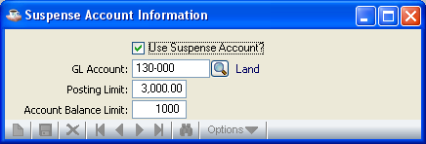

In the Use Suspense Account field …
If the ‘Use Suspense Account?’ checkbox is checked, it indicates Suspense Account is Used. If the ‘Use Suspense Account?’ is unchecked, it shows the Suspense Account is not used and the other fields are disabled. For change the other fields, you need to checked this field.

In the GL Account field …
• Enable when the ‘Use Suspense Account’ checkbox is checked. Enter the GL Account.
- Click the Find button to select from a list of all valid codes.

In the Posting Limit field …
Enable when the ‘Use Suspense Account’ is checked. Enter the posting limit of the GL Account you selected.

In the Account Balance Limit field …
This field is enabled only when the ‘Use Suspense Account’ is checked. Enter the Account Balance limit of the GL Account you selected.

- Click the Save button to save the details.
- Click the Close Window button to return to the Parameters Menu.

If you attempt to leave with out saving details by clicking Close Window, the module will issue a confirmation box as follows:

- Click Yes to save the current record and return to Parameters Menu

- Click No to return to the Parameters Menu without saving the current record.
- Click Cancel or the Close Window button to return to the current ‘Suspense Account Information’ Screen

Retained Earnings Account
• Enter the retained earnings account number.
- Click the Find button to select from a list of all valid accounts.

NOTE: This number is required for the year-end closing process to operate properly. This account must be set up as a valid account in the chart of accounts.

Chart of Accounts Breaks
This option establishes breaks between different types of general ledger accounts to group them together and produce subtotals on the standard AddonSoftware financial reports (Trial Balance, Balance Sheet, Profit and Loss Statement). At a minimum, account breaks should be defined for assets, liabilities, capital (owner's equity), income, and expenses, although they can be called by other names. The breaks established here have no effect on custom financial reports set up in Financial Report Maintenance.

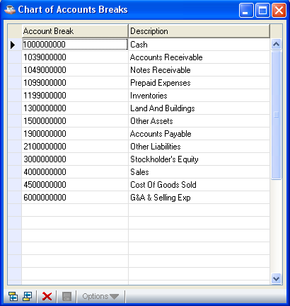

In the Account Break field...
• Enter a chart of accounts break number.

Account Break Example
When the first expense account is 501-00 and the last income account is 475-00, enter 500-00 as the account break for expenses. Since it is not a valid account number, it will produce a break between income and expenses.

NOTE: The breaks do not have to be entered in sequence. The entries will be re-sorted automatically after they are entered.

In the Description field...
• Enter a description for each account, up to 20 characters in length.

- Click the Save button to save the modified or new details in the grid.
- Click the Delete button to delete the current line.
- Click the ‘Add to end’ button to add a new record after the last current row in the grid.
- Click the ‘Insert before’ button to insert a new record before the currently selected row in the grid.

If you attempt to leave without saving details by clicking Close Window, the module will issue a confirmation box as follows:

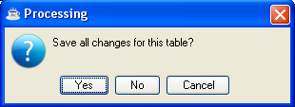

- Click Yes to save the current record and return to Payments Menu.
- Click No to return to the Payments Menu without saving the current record.
- Click Cancel or the Close Window button to return to the current ‘Chart of Accounts Break’ Screen

Default Display Columns
This option determines the columns of summarized activity to be displayed on screen, and in what order, for account maintenance and budget maintenance tasks. It also determines the columns to appear on the Summary Activity Report and the Budget Revision Report.

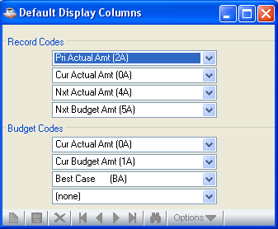

- Click the Save button to save the modified or new details in the grid.

If you attempt to leave with out saving details by clicking Close Window, the module will issue a confirmation box as follows:

- Click Yes to save the current record and return to Payments Menu.
- Click No to return to the Payments Menu without saving the current record.
- Click Cancel or the Close Window button to return to the current ‘Chart of Accounts Break’ Screen

General Ledger Utilities

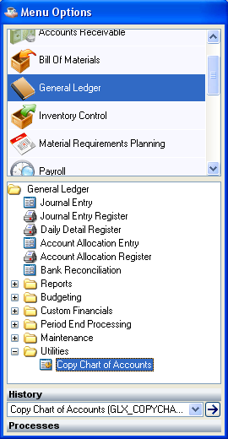
General Ledger Utilities Menu

Function
The General Ledger Utilities Menu provides access to the Rebuild GL Cross-References task. Only an operator with a security level of 9 may access the General Ledger Utilities Menu. The menu jumping feature in System Maintenance, User Maintenance can also be disabled to prevent access to the GLX menu.

Copy Chart of Accounts

This option copies chart of accounts from one company to another company in the specified beginning and ending GL Account.

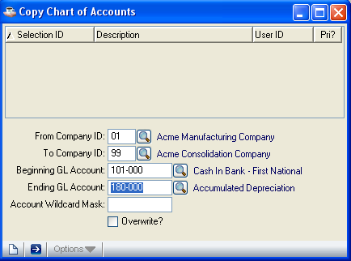

In the From Company ID field...
Source Company ID you need to give, means which company’s data you want to copy.

- Enter a valid two character Company ID code
- Click the Find button to select from a list of all valid codes

In the To Company ID field...
Destination Company ID you need to give, means the company which got the copied company’s Account information.

- Enter a valid two character Company ID code
- Click the Find button to select from a list of all valid codes

In the Beginning GL Account field...
The beginning GL account no you need to give

- Enter a valid six character Company ID code
- Click the Find button to select from a list of all valid codes

In the Ending GL Account field...
The ending GL account no you need to give

- Enter a valid six character Company ID code
- Click the Find button to select from a list of all valid codes

In the Account Wildcard Mask field...

